Plated UI review
  - October 1 2026
Review the screens and write your feedback beside each image. Use the screen ID when referring to a change so we can turn your notes into a precise implementation list.

62 app screens and states
Also includes 27 widget and timer layouts and 2 recipe share extension states.
Each review page has a screenshot, its ID and an editable feedback area. Add Word comments directly to the page if you prefer. Mark your decision as Keep, Change or Discuss and give changes a priority of High, Medium or Low.

Overall direction

What feels right
Write feedback here.

What should change across the app
Write feedback here.

Highest priority changes
Write feedback here.

Screen index
App screens use A IDs. Widgets and timer layouts use W IDs. Share extension screens use X IDs.
Screen ID | Screen or state
A01 | Week plan
A02 | Month plan
A03 | Day details
A04 | Plan a night
A05 | Move a meal
A06 | Recipes
A07 | Recipe filters
A08 | Recipe details
A09 | Planned recipe
A10 | New recipe
A11 | Edit recipe
A12 | Import recipe
A13 | Assign recipe to a night
A14 | Recipe picker
A15 | Share recipe
A16 | Cooking without written steps
A17 | Groceries
A18 | Table feed
A19 | Discover
A20 | Post thread
A21 | Create a post
A22 | Edit post
A23 | Ask the Table
A24 | Table seats
A25 | Activity

Screen index continued
Screen ID | Screen or state
A26 | My profile
A27 | Other person profile
A28 | Edit profile
A29 | Household
A30 | Add household member
A31 | Household statistics
A32 | Awards
A33 | Settings
A34 | Gathering
A35 | Join household failure
A36 | Create menu
A37 | Sign in
A38 | Profile setup
A39 | Contacts onboarding
A40 | Tour tonight
A41 | Tour plan ahead
A42 | Tour recipes
A43 | Tour Table
A44 | Launch opener
A45 | Cooking ingredients
A46 | Cooking complete
A47 | Groceries by meal
A48 | Grocery meal picker
A49 | Grocery shopping options
A50 | Post a question

Screen index continued
Screen ID | Screen or state
A51 | Award detail
A52 | Apple sign in fallback
A53 | Plated Plus
A54 | Prongsby
A55 | Cooking with written steps
A56 | Cooking with active timer
A57 | Household settings
A58 | Plan calendar picker
A59 | Recipe ingredient sheet
A60 | Household badge detail
A61 | Grocery shopping date
A62 | Activity with updates

Screen index continued
Screen ID | Screen or state
W01 | Tonight widget small
W02 | Tonight widget medium
W03 | Tonight widget large
W04 | Table widget small
W05 | Table widget medium
W06 | Table widget large
W07 | Cookbook widget small
W08 | Cookbook widget medium
W09 | Grocery widget small
W10 | Grocery widget medium
W11 | Grocery widget large
W12 | Whose turn widget small
W13 | Whose turn widget medium
W14 | Tonight lock screen inline
W15 | Tonight lock screen circular
W16 | Tonight lock screen rectangular
W17 | Groceries lock screen inline
W18 | Groceries lock screen circular
W19 | Groceries lock screen rectangular
W20 | Whose turn lock screen inline
W21 | Whose turn lock screen circular
W22 | Whose turn lock screen rectangular
W23 | Cook timer live activity
W24 | Cook timer expired
W25 | Dynamic Island expanded layout

Screen index continued
Screen ID | Screen or state
W26 | Dynamic Island compact layout
W27 | Dynamic Island minimal layout

Screen index continued
Screen ID | Screen or state
X01 | Share extension sending
X02 | Share extension saved

A01 Week plan
Current working tree rendered with sample data
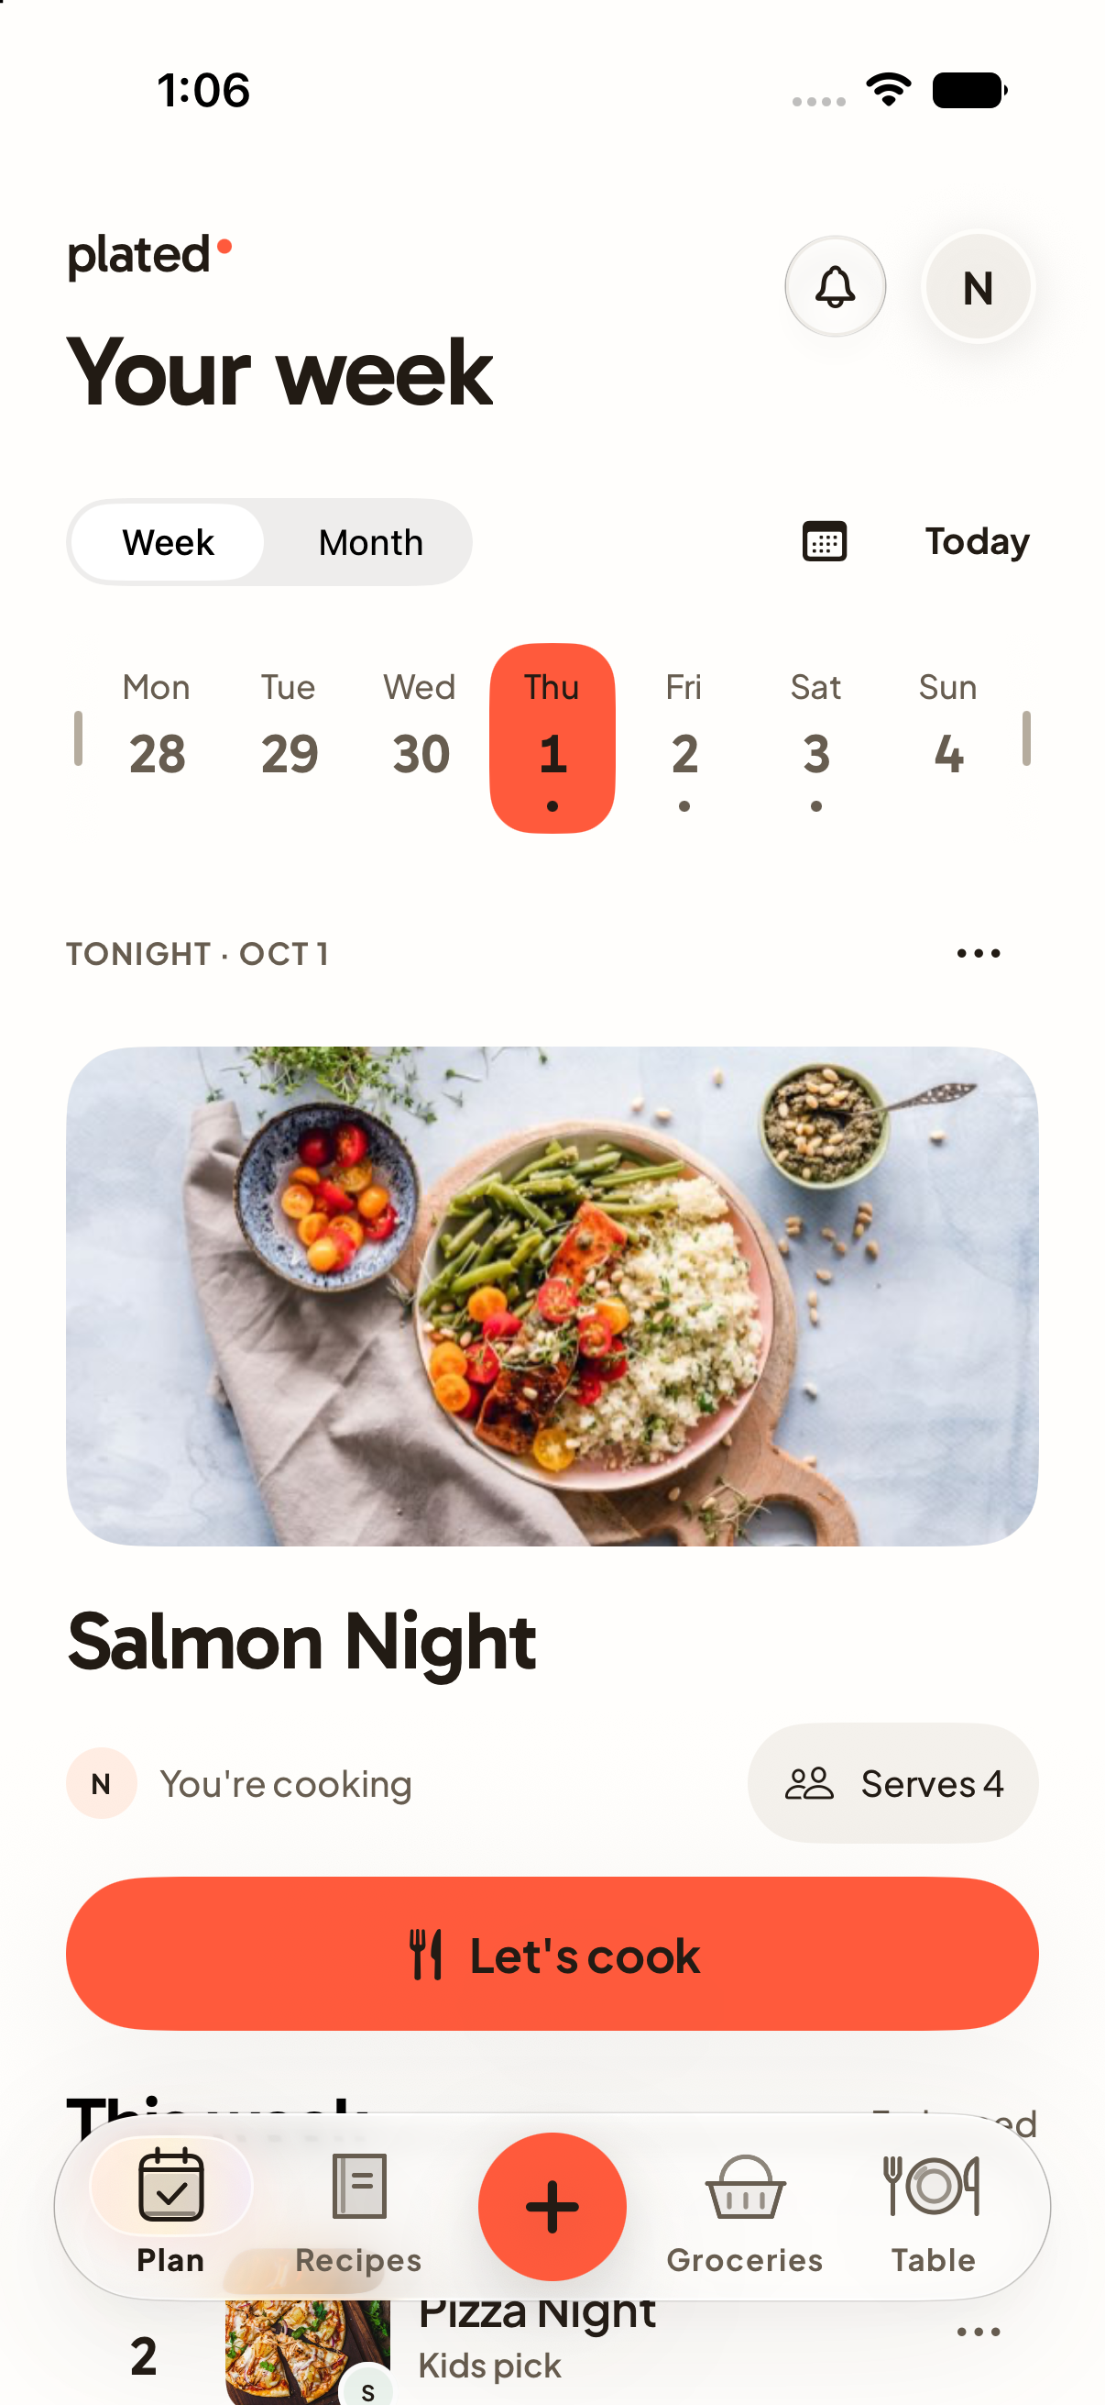  A01 | Decision  Keep / Change / Discuss  Priority  High / Medium / Low  What works  Write feedback here.  What to change  Write feedback here.  Desired result  Write feedback here.

A02 Month plan
Current working tree rendered with sample data
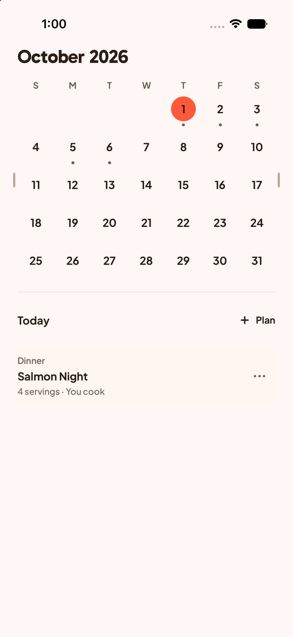  A02 | Decision  Keep / Change / Discuss  Priority  High / Medium / Low  What works  Write feedback here.  What to change  Write feedback here.  Desired result  Write feedback here.

A03 Day details
Current working tree rendered with sample data
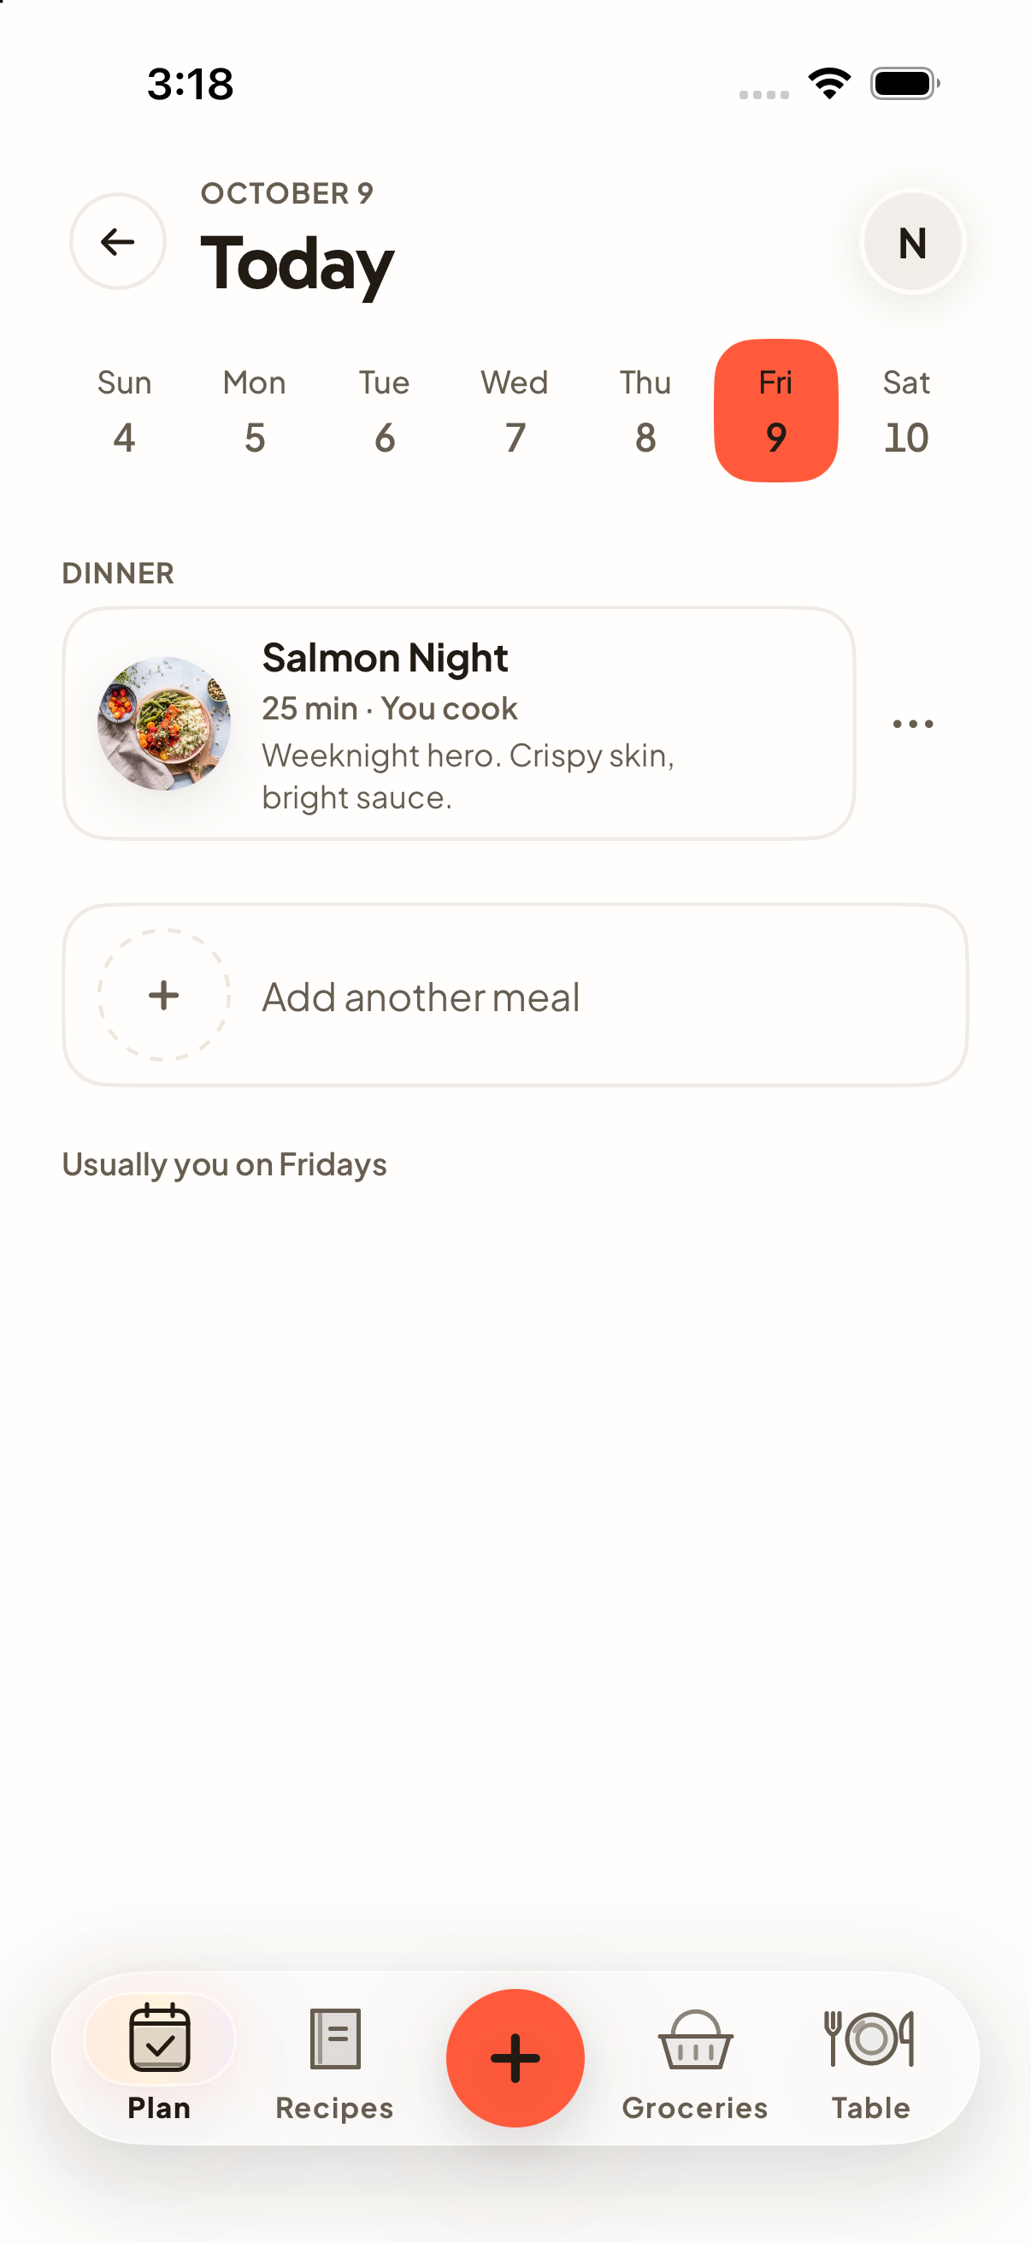  A03 | Decision  Keep / Change / Discuss  Priority  High / Medium / Low  What works  Write feedback here.  What to change  Write feedback here.  Desired result  Write feedback here.

A04 Plan a night
Current working tree rendered with sample data
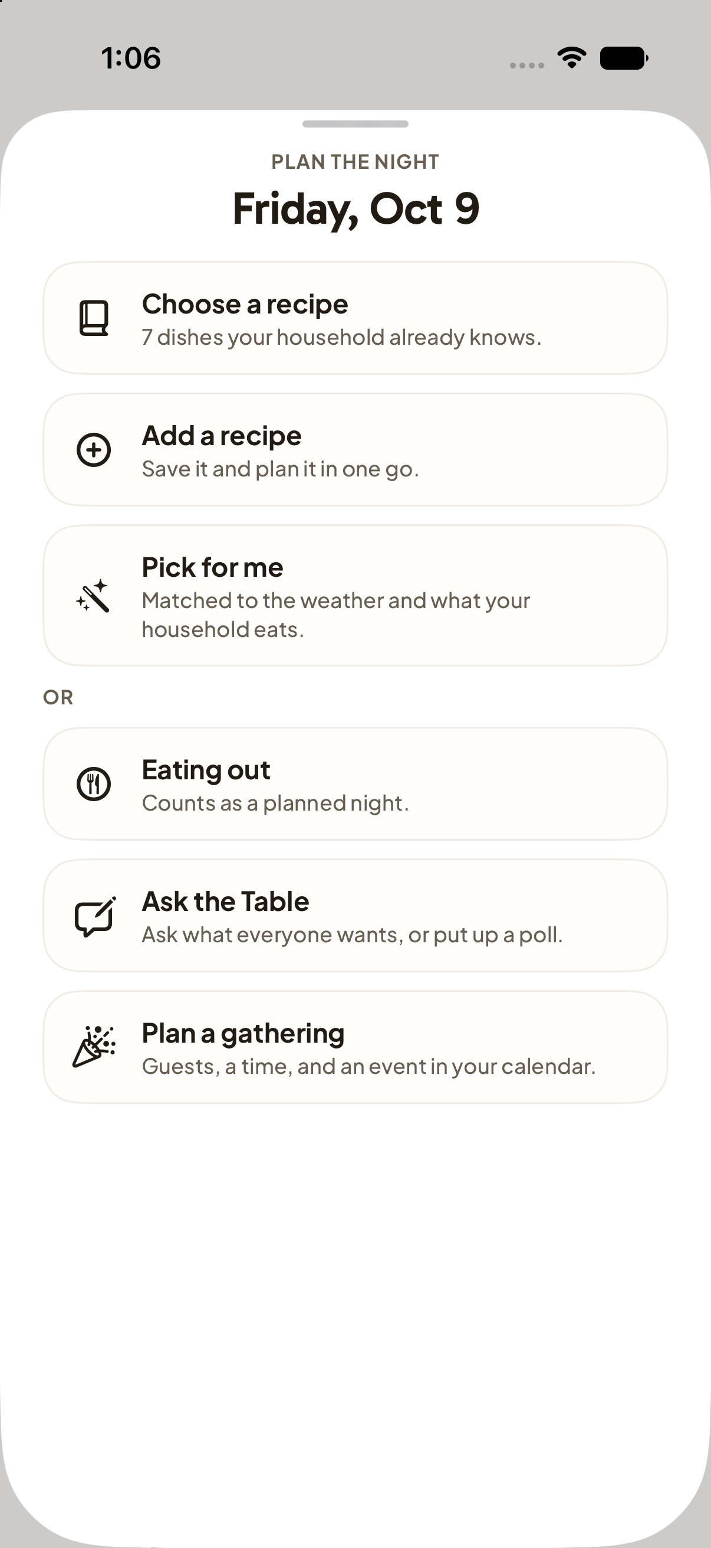  A04 | Decision  Keep / Change / Discuss  Priority  High / Medium / Low  What works  Write feedback here.  What to change  Write feedback here.  Desired result  Write feedback here.

A05 Move a meal
Current working tree rendered with sample data
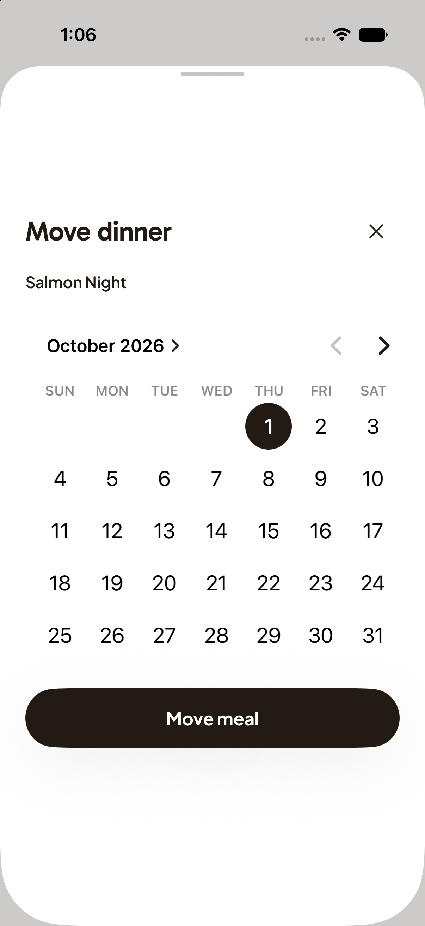  A05 | Decision  Keep / Change / Discuss  Priority  High / Medium / Low  What works  Write feedback here.  What to change  Write feedback here.  Desired result  Write feedback here.

A06 Recipes
Current working tree rendered with sample data
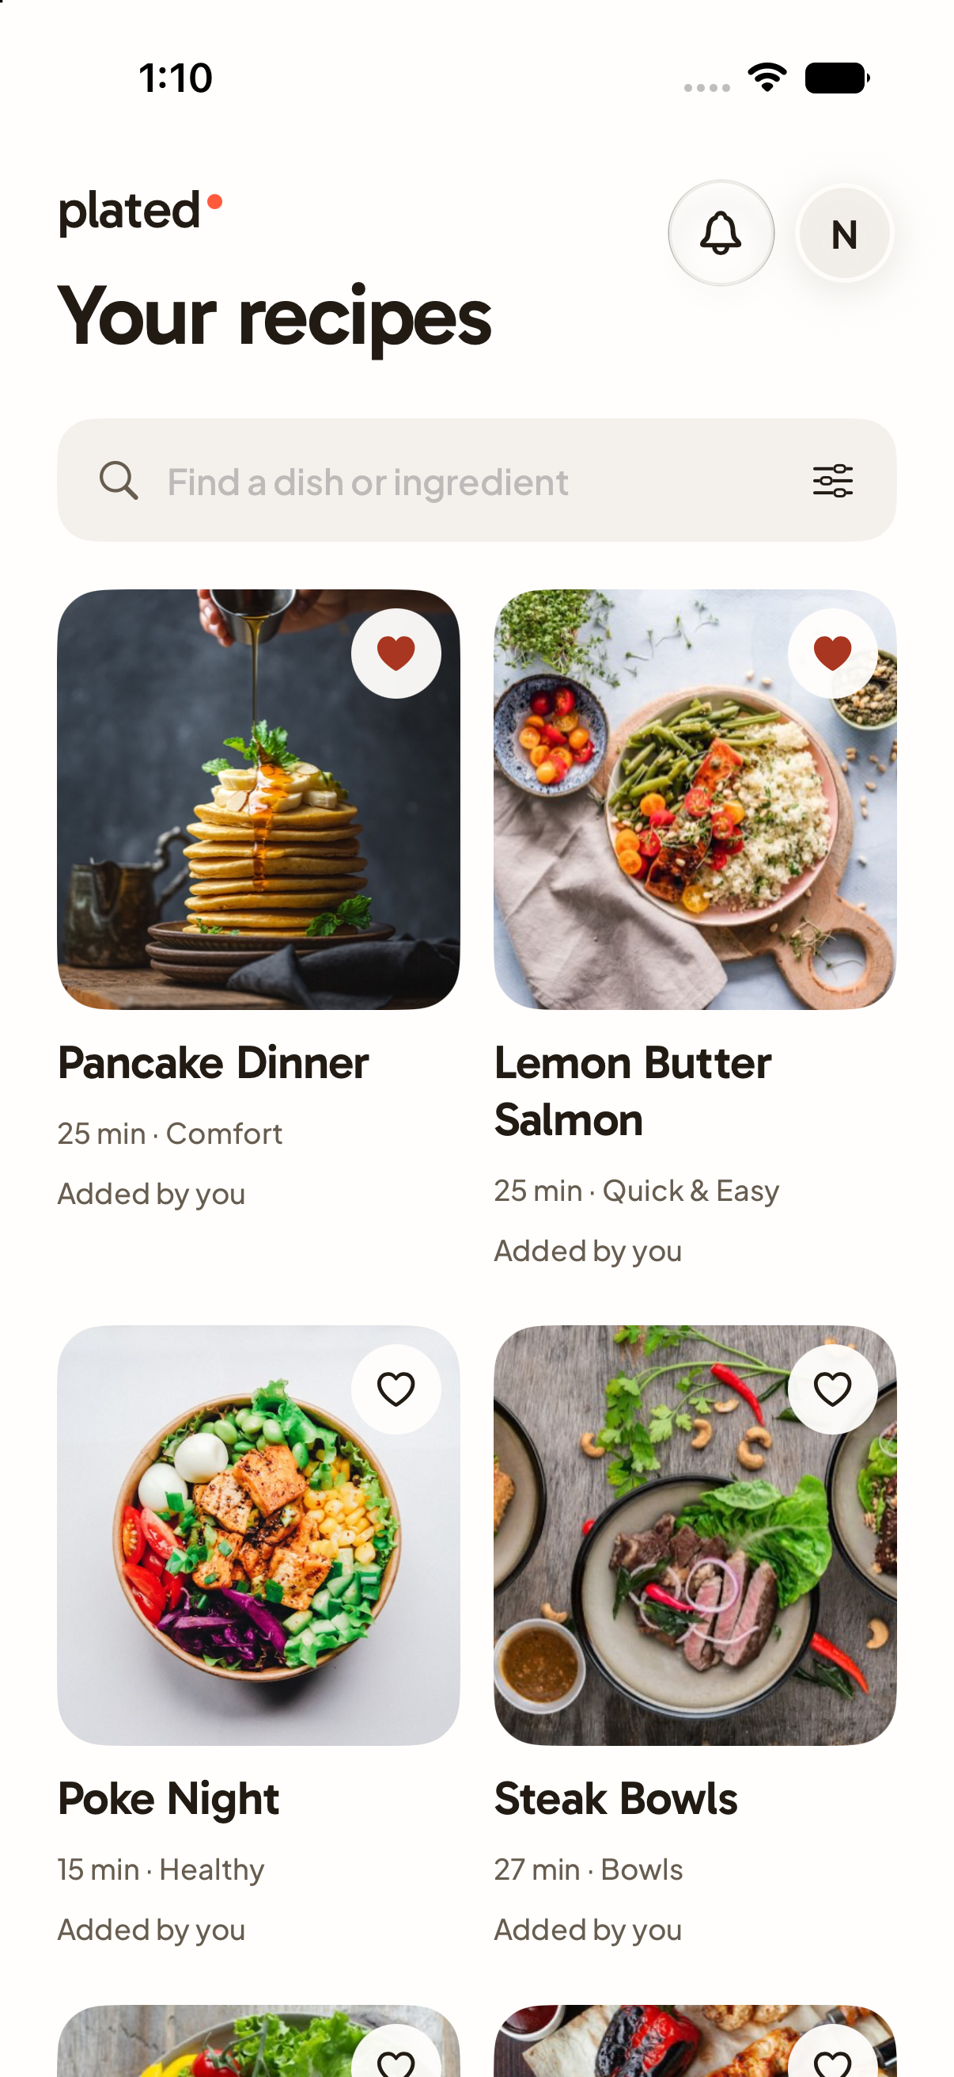  A06 | Decision  Keep / Change / Discuss  Priority  High / Medium / Low  What works  Write feedback here.  What to change  Write feedback here.  Desired result  Write feedback here.

A07 Recipe filters
Current working tree rendered with sample data
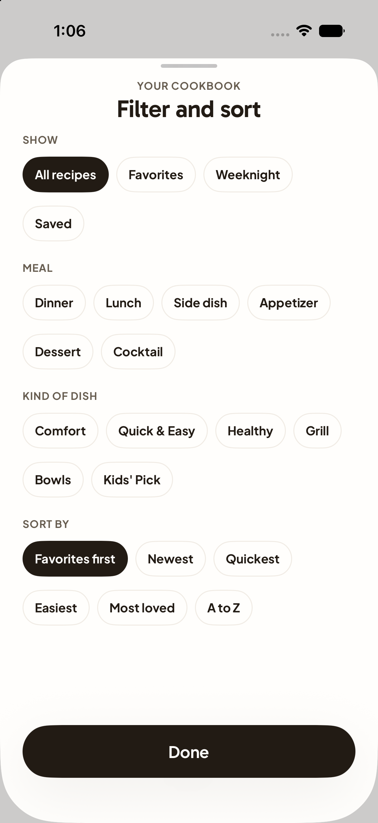  A07 | Decision  Keep / Change / Discuss  Priority  High / Medium / Low  What works  Write feedback here.  What to change  Write feedback here.  Desired result  Write feedback here.

A08 Recipe details
Current working tree rendered with sample data
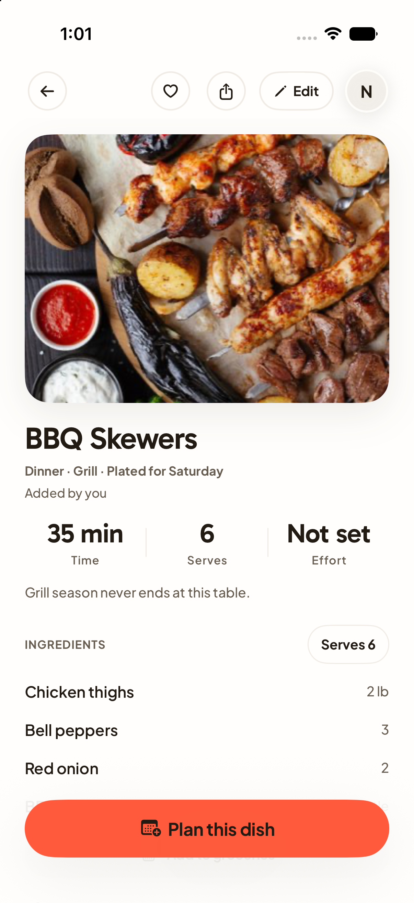  A08 | Decision  Keep / Change / Discuss  Priority  High / Medium / Low  What works  Write feedback here.  What to change  Write feedback here.  Desired result  Write feedback here.

A09 Planned recipe
Current working tree rendered with sample data
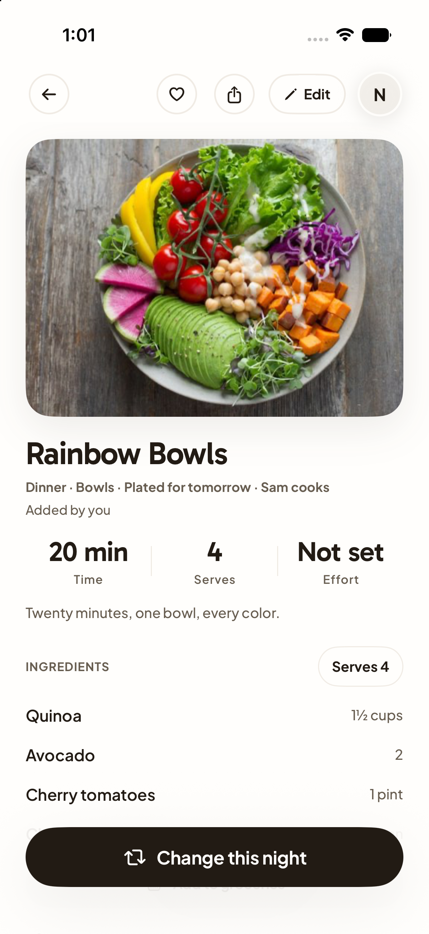  A09 | Decision  Keep / Change / Discuss  Priority  High / Medium / Low  What works  Write feedback here.  What to change  Write feedback here.  Desired result  Write feedback here.

A10 New recipe
Current working tree rendered with sample data
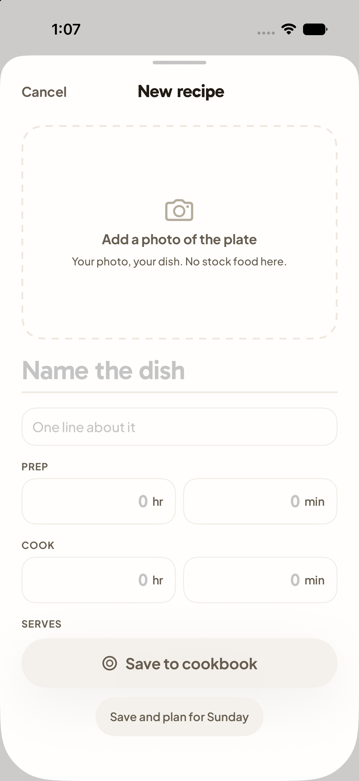  A10 | Decision  Keep / Change / Discuss  Priority  High / Medium / Low  What works  Write feedback here.  What to change  Write feedback here.  Desired result  Write feedback here.

A11 Edit recipe
Current working tree rendered with sample data
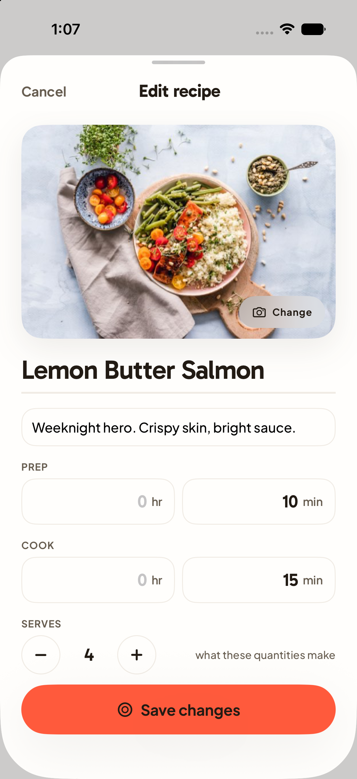  A11 | Decision  Keep / Change / Discuss  Priority  High / Medium / Low  What works  Write feedback here.  What to change  Write feedback here.  Desired result  Write feedback here.

A12 Import recipe
Current working tree rendered with sample data
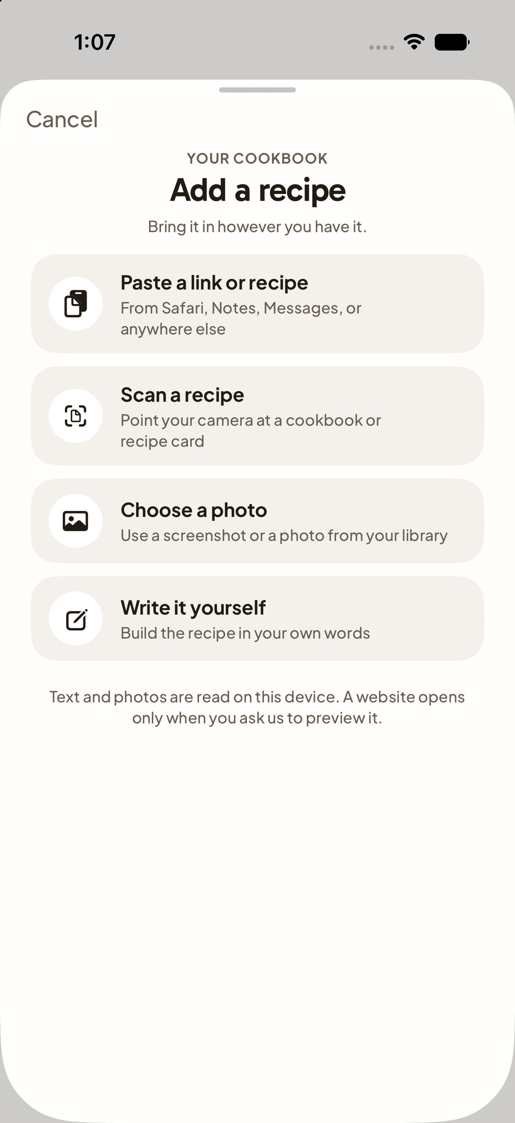  A12 | Decision  Keep / Change / Discuss  Priority  High / Medium / Low  What works  Write feedback here.  What to change  Write feedback here.  Desired result  Write feedback here.

A13 Assign recipe to a night
Current working tree rendered with sample data
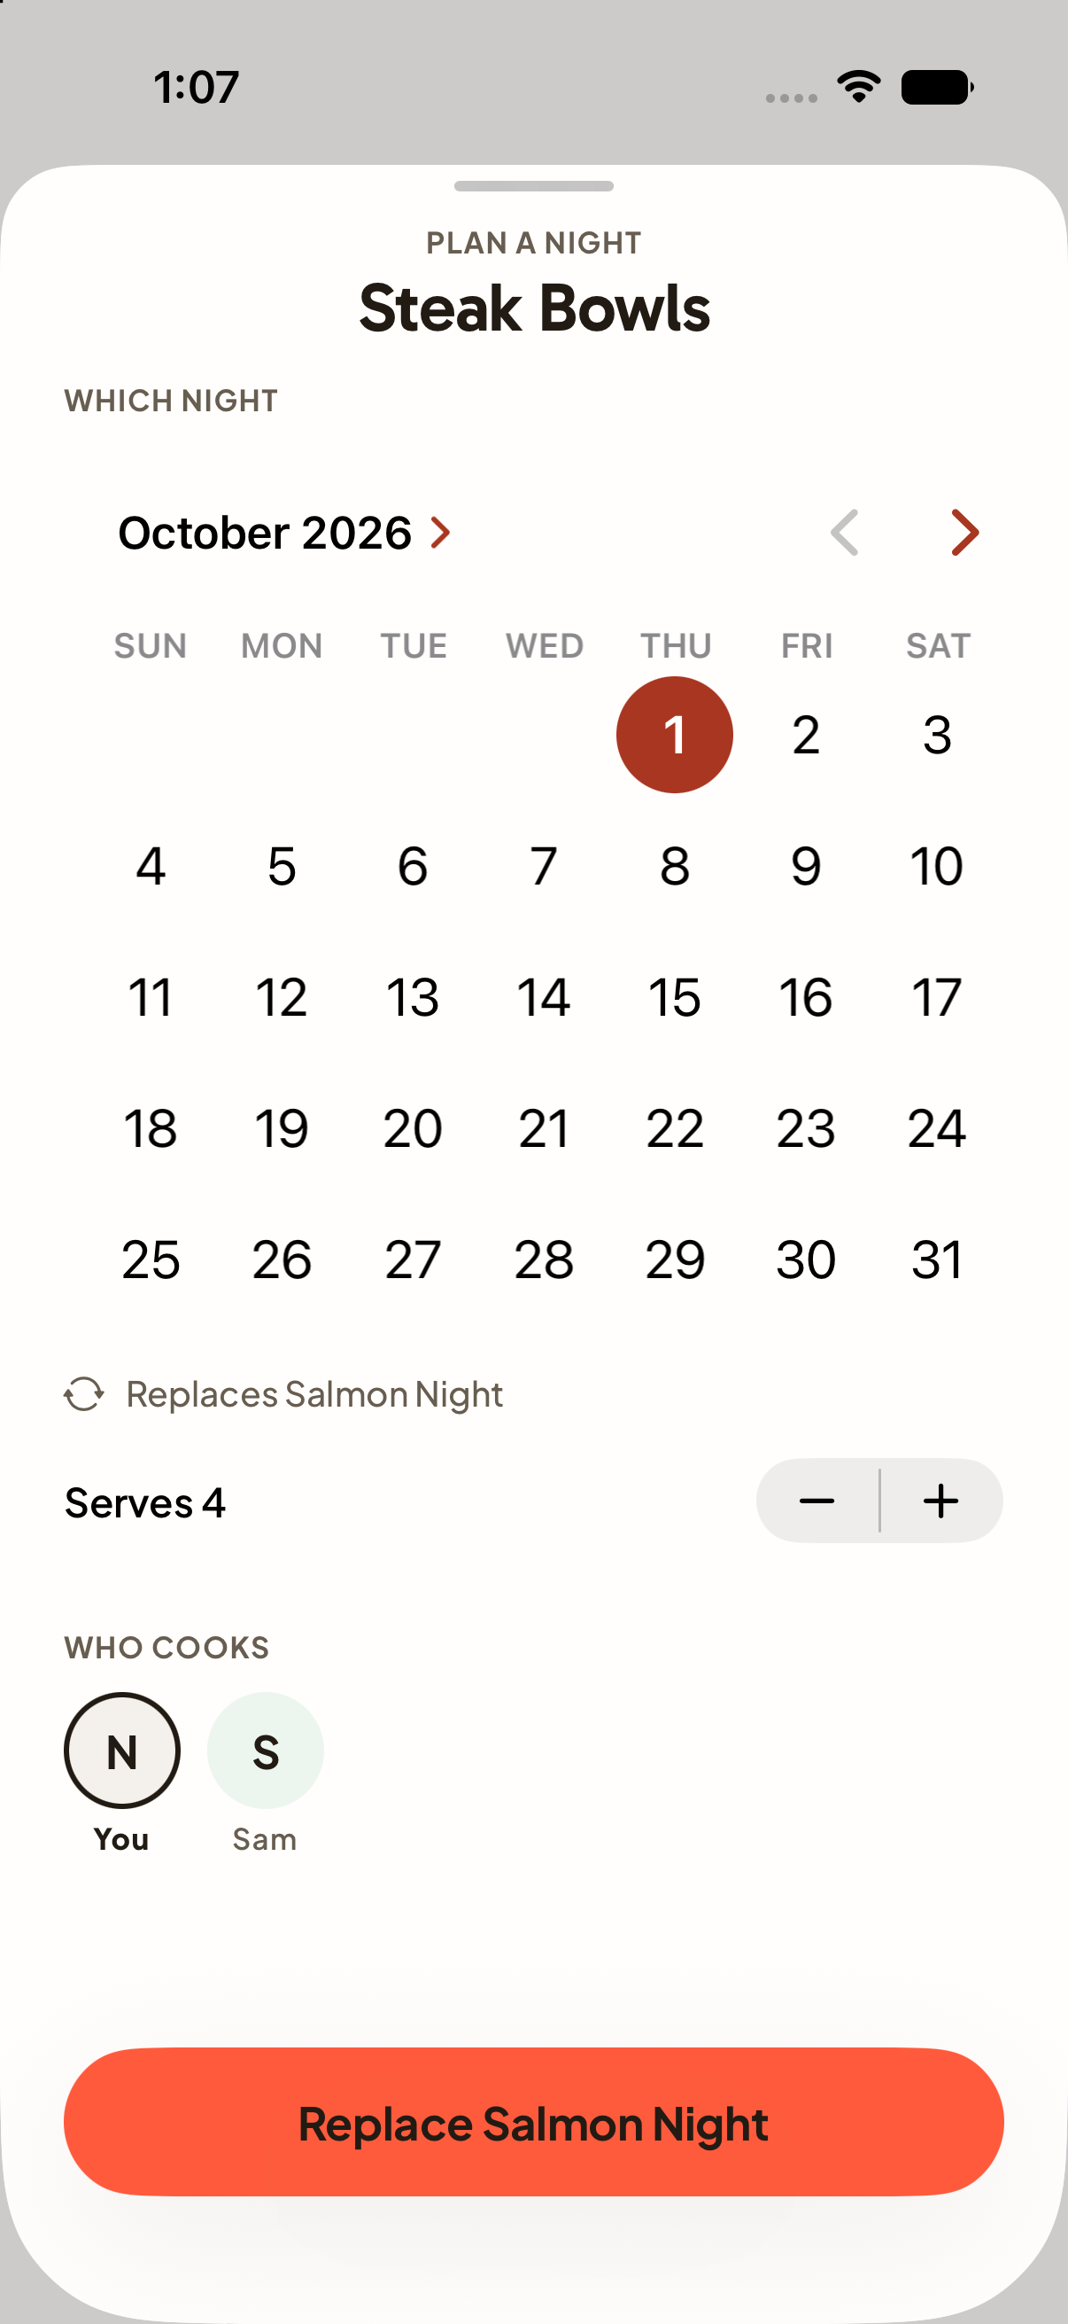  A13 | Decision  Keep / Change / Discuss  Priority  High / Medium / Low  What works  Write feedback here.  What to change  Write feedback here.  Desired result  Write feedback here.

A14 Recipe picker
Current working tree rendered with sample data
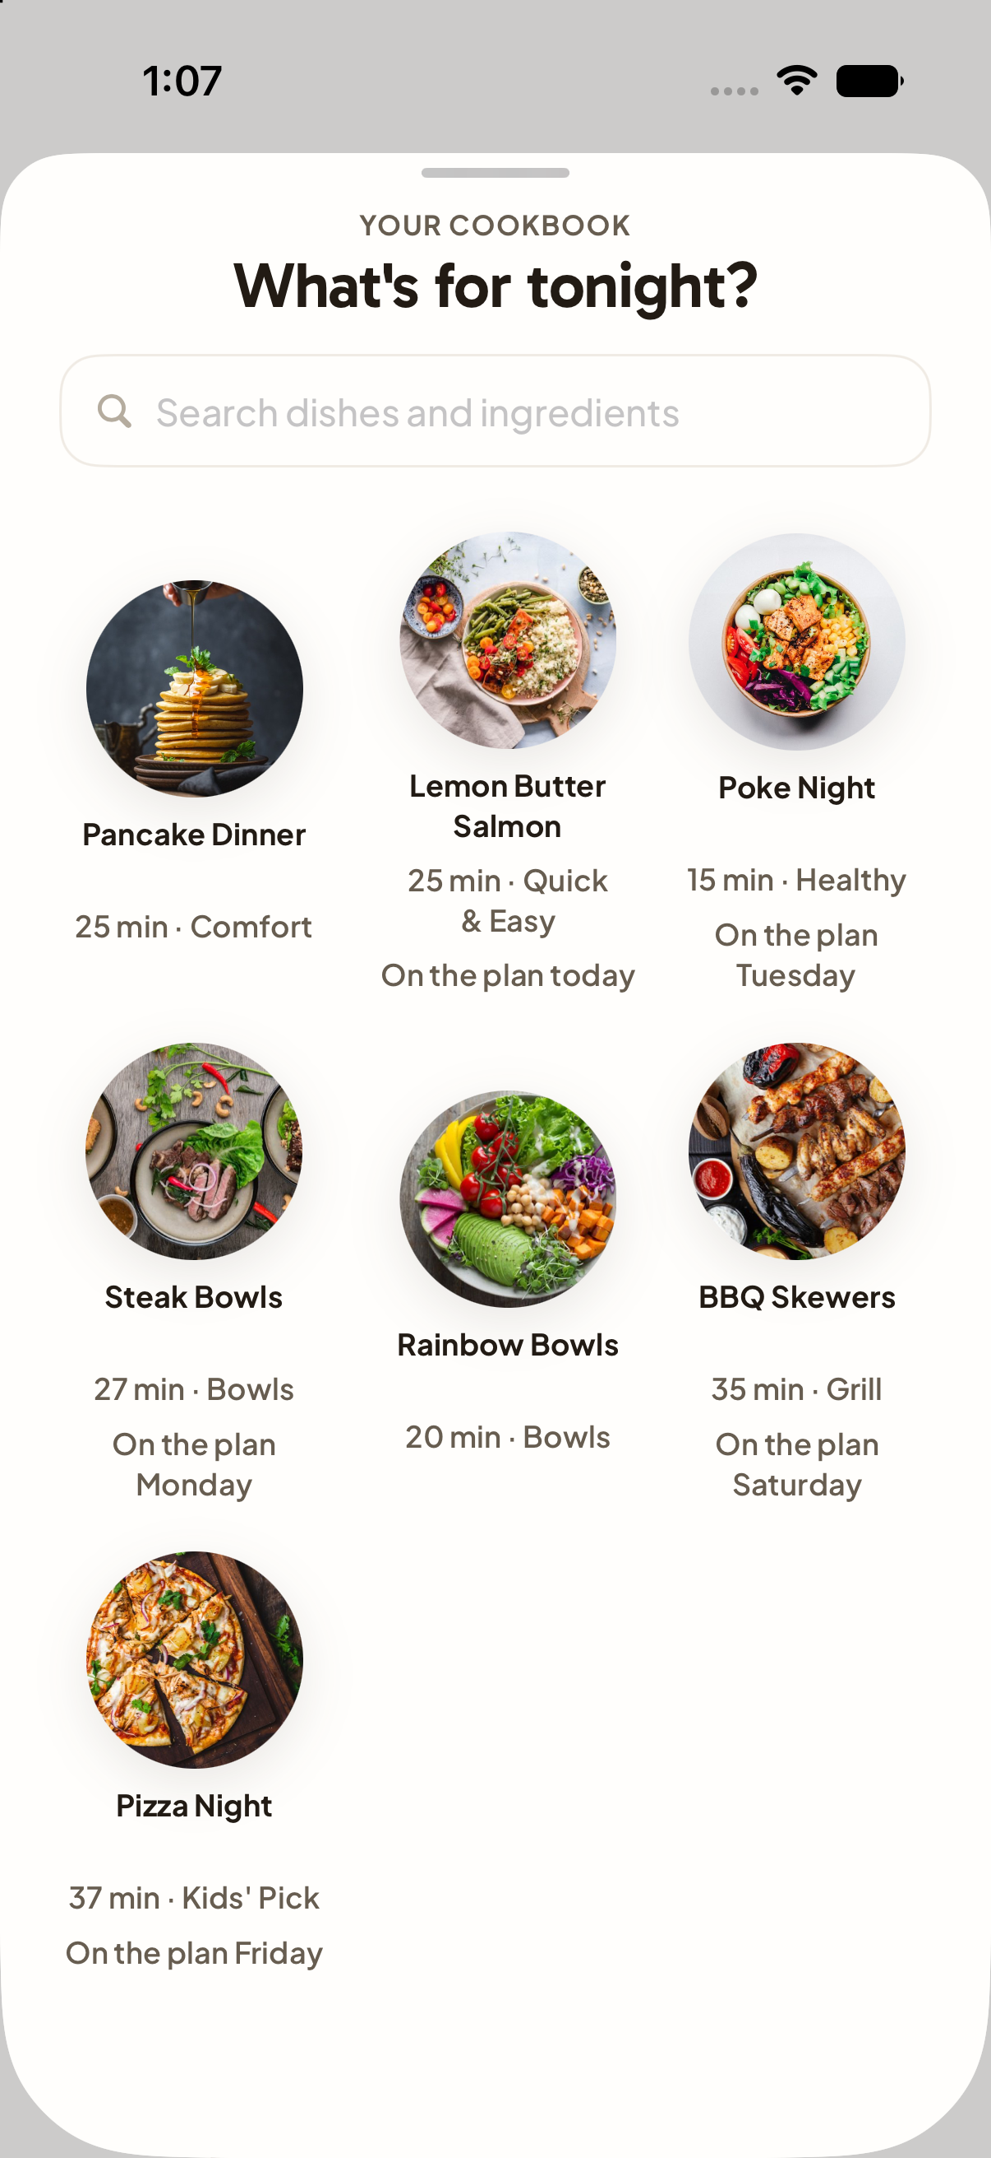  A14 | Decision  Keep / Change / Discuss  Priority  High / Medium / Low  What works  Write feedback here.  What to change  Write feedback here.  Desired result  Write feedback here.

A15 Share recipe
Current working tree rendered with sample data
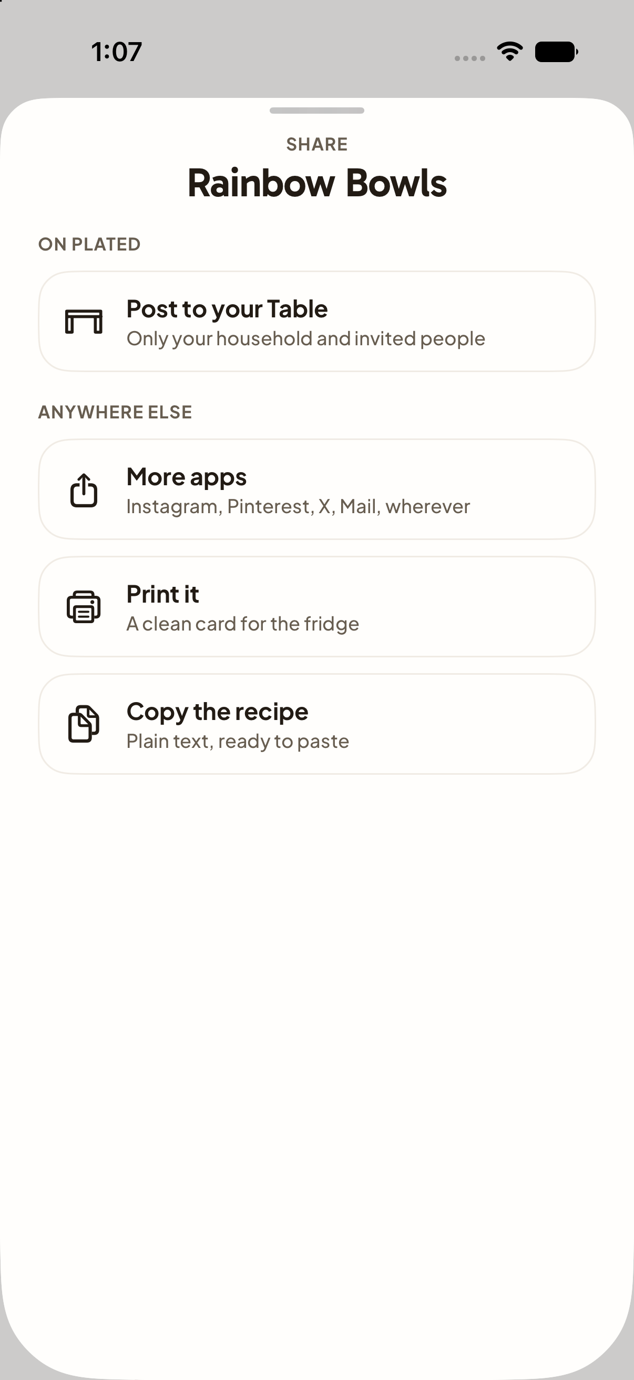  A15 | Decision  Keep / Change / Discuss  Priority  High / Medium / Low  What works  Write feedback here.  What to change  Write feedback here.  Desired result  Write feedback here.

A16 Cooking without written steps
Current working tree rendered with sample data
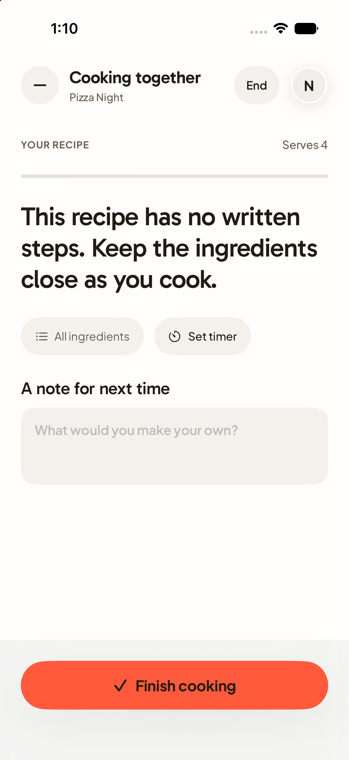  A16 | Decision  Keep / Change / Discuss  Priority  High / Medium / Low  What works  Write feedback here.  What to change  Write feedback here.  Desired result  Write feedback here.

A17 Groceries
Current working tree rendered with sample data
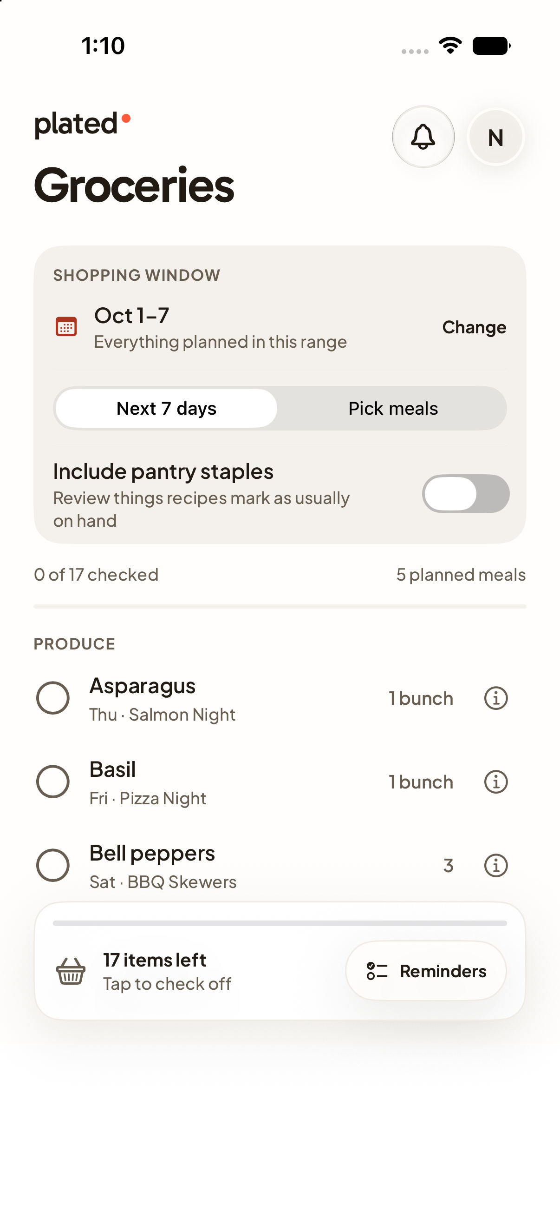  A17 | Decision  Keep / Change / Discuss  Priority  High / Medium / Low  What works  Write feedback here.  What to change  Write feedback here.  Desired result  Write feedback here.

A18 Table feed
Current working tree rendered with sample data
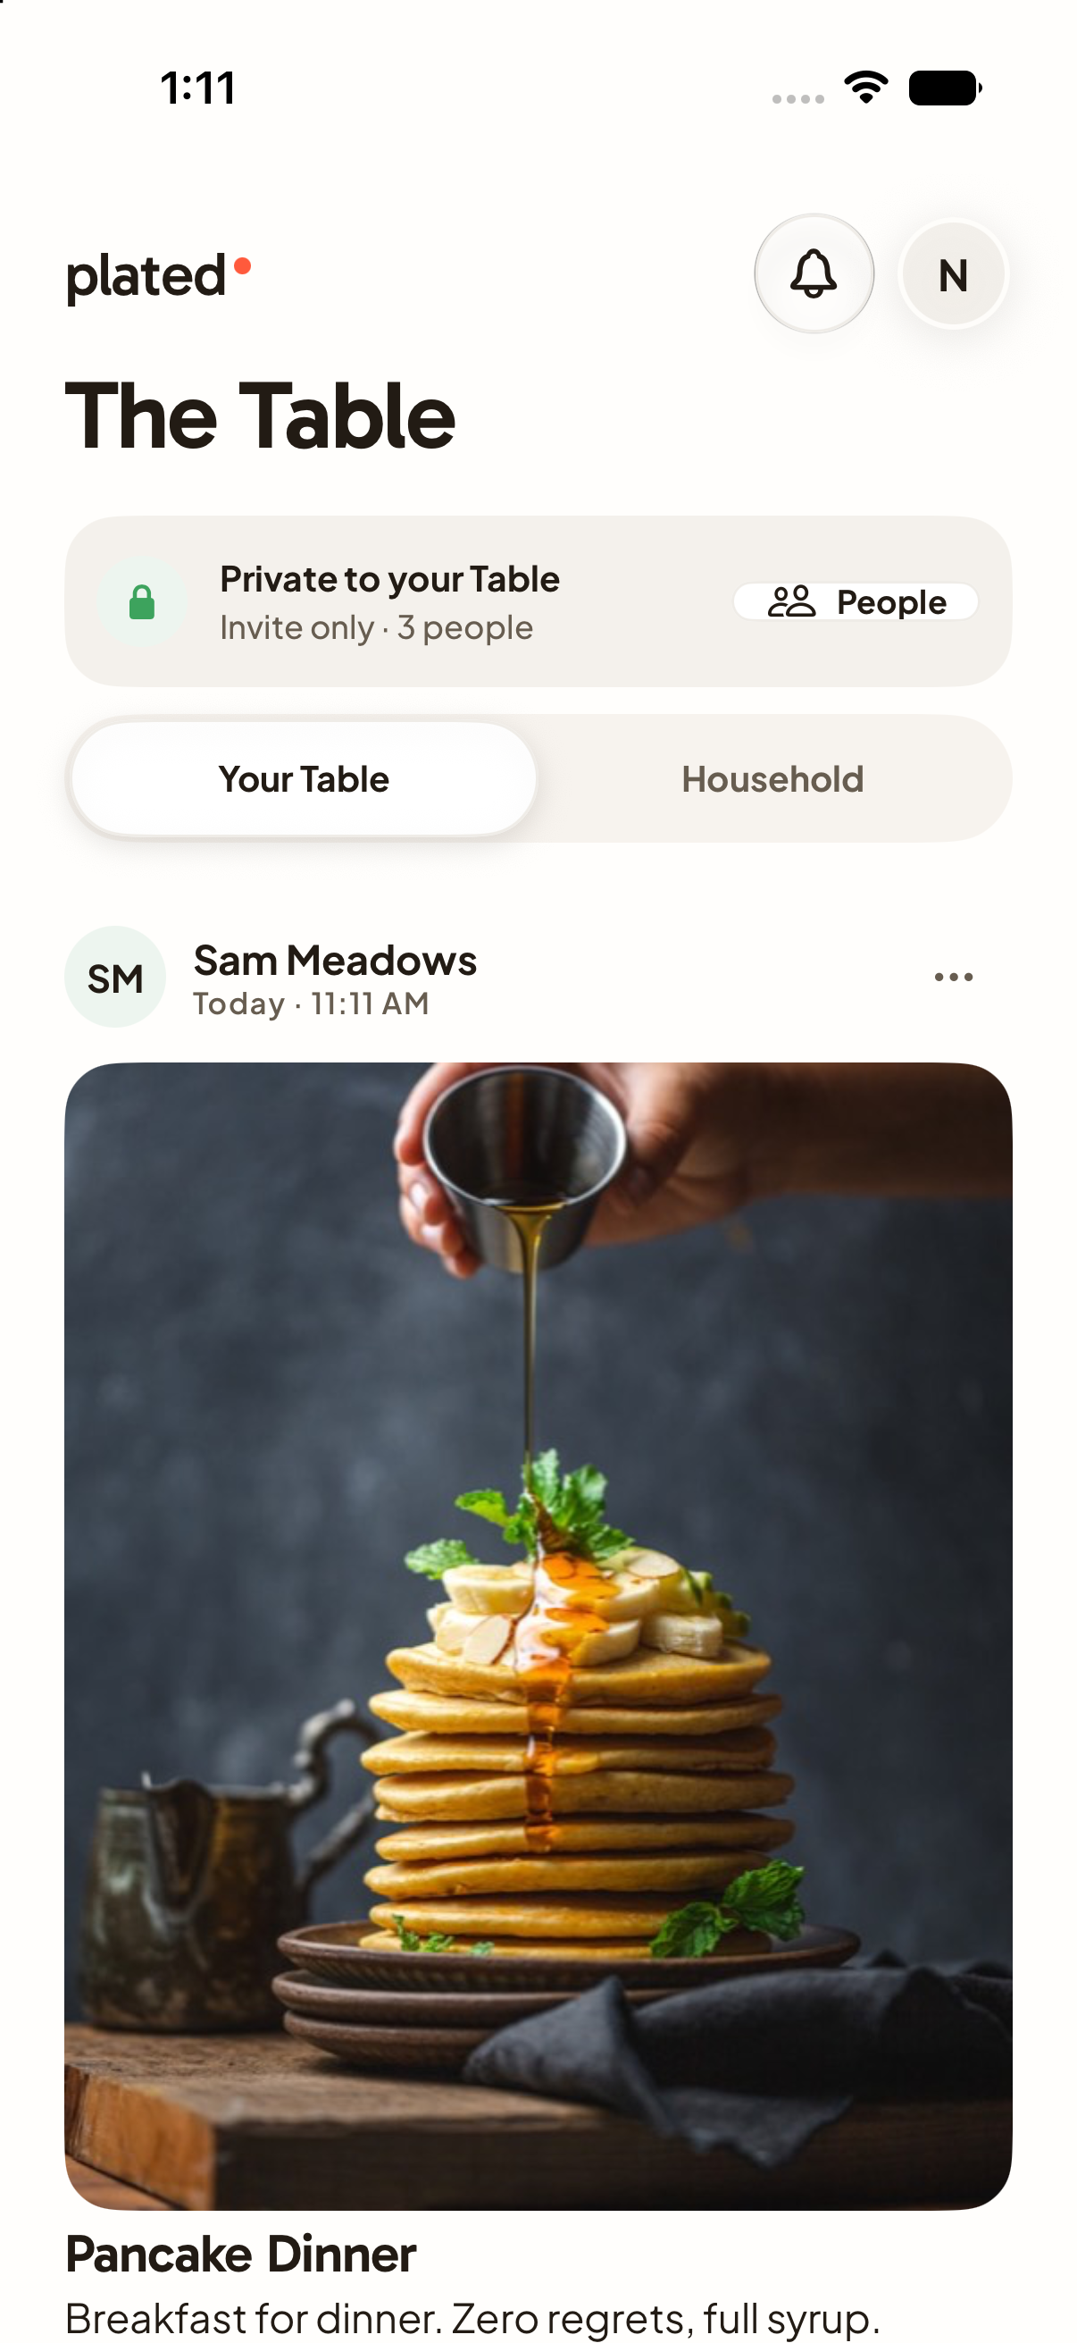  A18 | Decision  Keep / Change / Discuss  Priority  High / Medium / Low  What works  Write feedback here.  What to change  Write feedback here.  Desired result  Write feedback here.

A19 Discover
Current working tree rendered with sample data
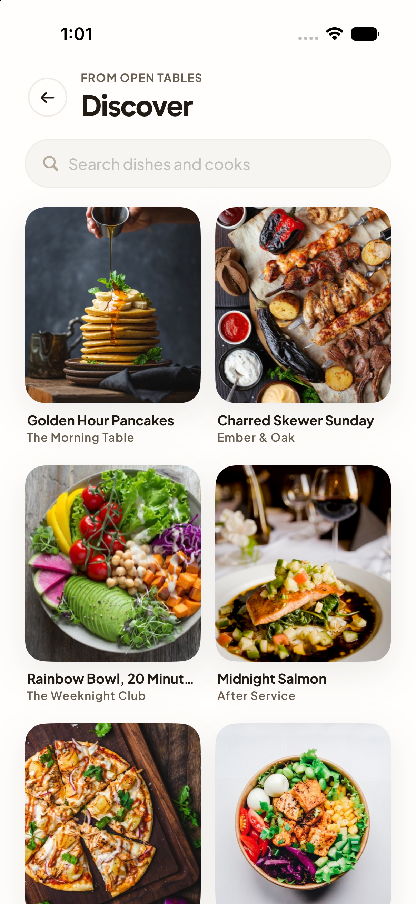  A19 | Decision  Keep / Change / Discuss  Priority  High / Medium / Low  What works  Write feedback here.  What to change  Write feedback here.  Desired result  Write feedback here.

A20 Post thread
Current working tree rendered with sample data
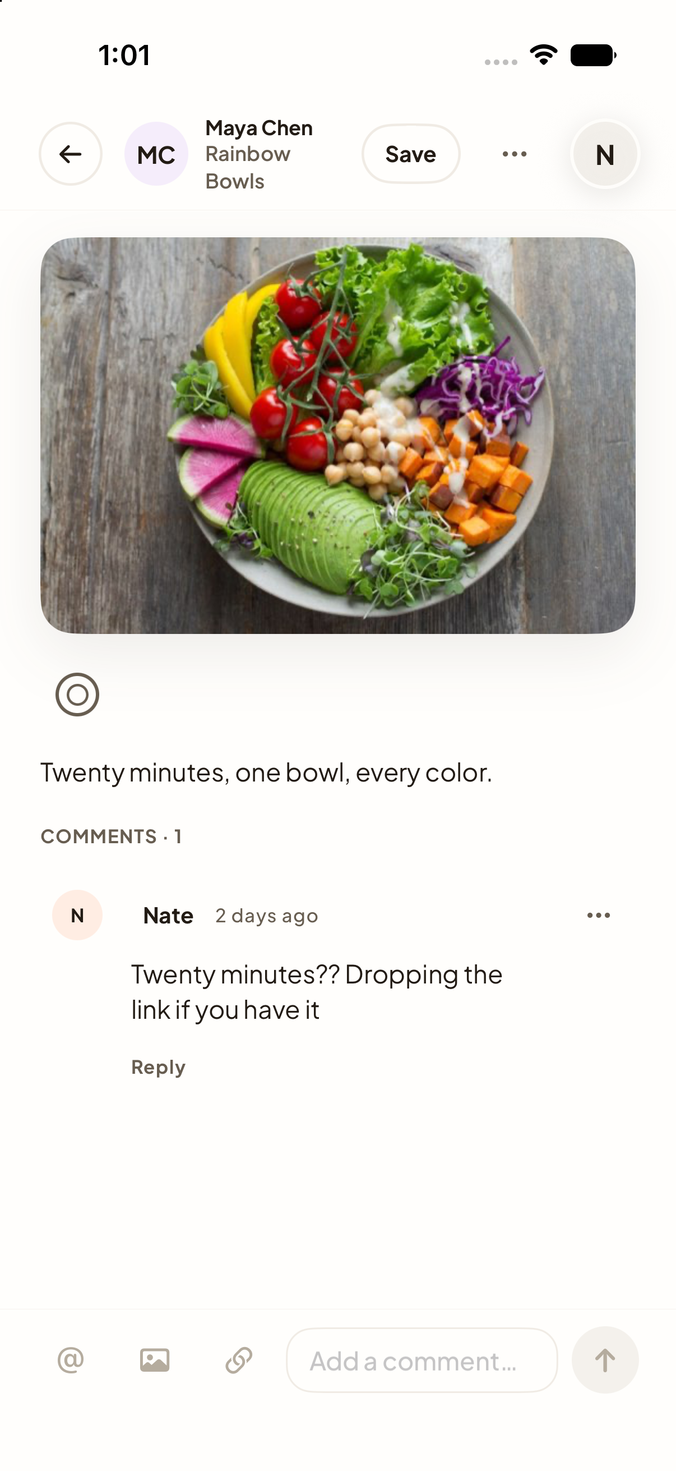  A20 | Decision  Keep / Change / Discuss  Priority  High / Medium / Low  What works  Write feedback here.  What to change  Write feedback here.  Desired result  Write feedback here.

A21 Create a post
Current working tree rendered with sample data
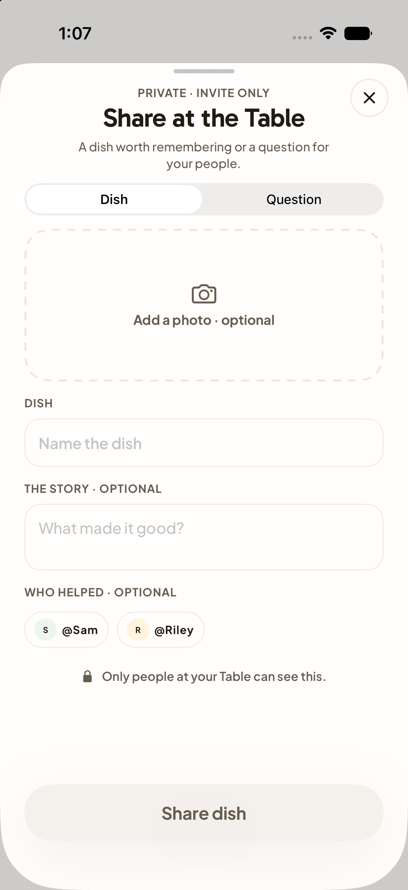  A21 | Decision  Keep / Change / Discuss  Priority  High / Medium / Low  What works  Write feedback here.  What to change  Write feedback here.  Desired result  Write feedback here.

A22 Edit post
Current working tree rendered with sample data
  A22 | Decision  Keep / Change / Discuss  Priority  High / Medium / Low  What works  Write feedback here.  What to change  Write feedback here.  Desired result  Write feedback here.

A23 Ask the Table
Current working tree rendered with sample data
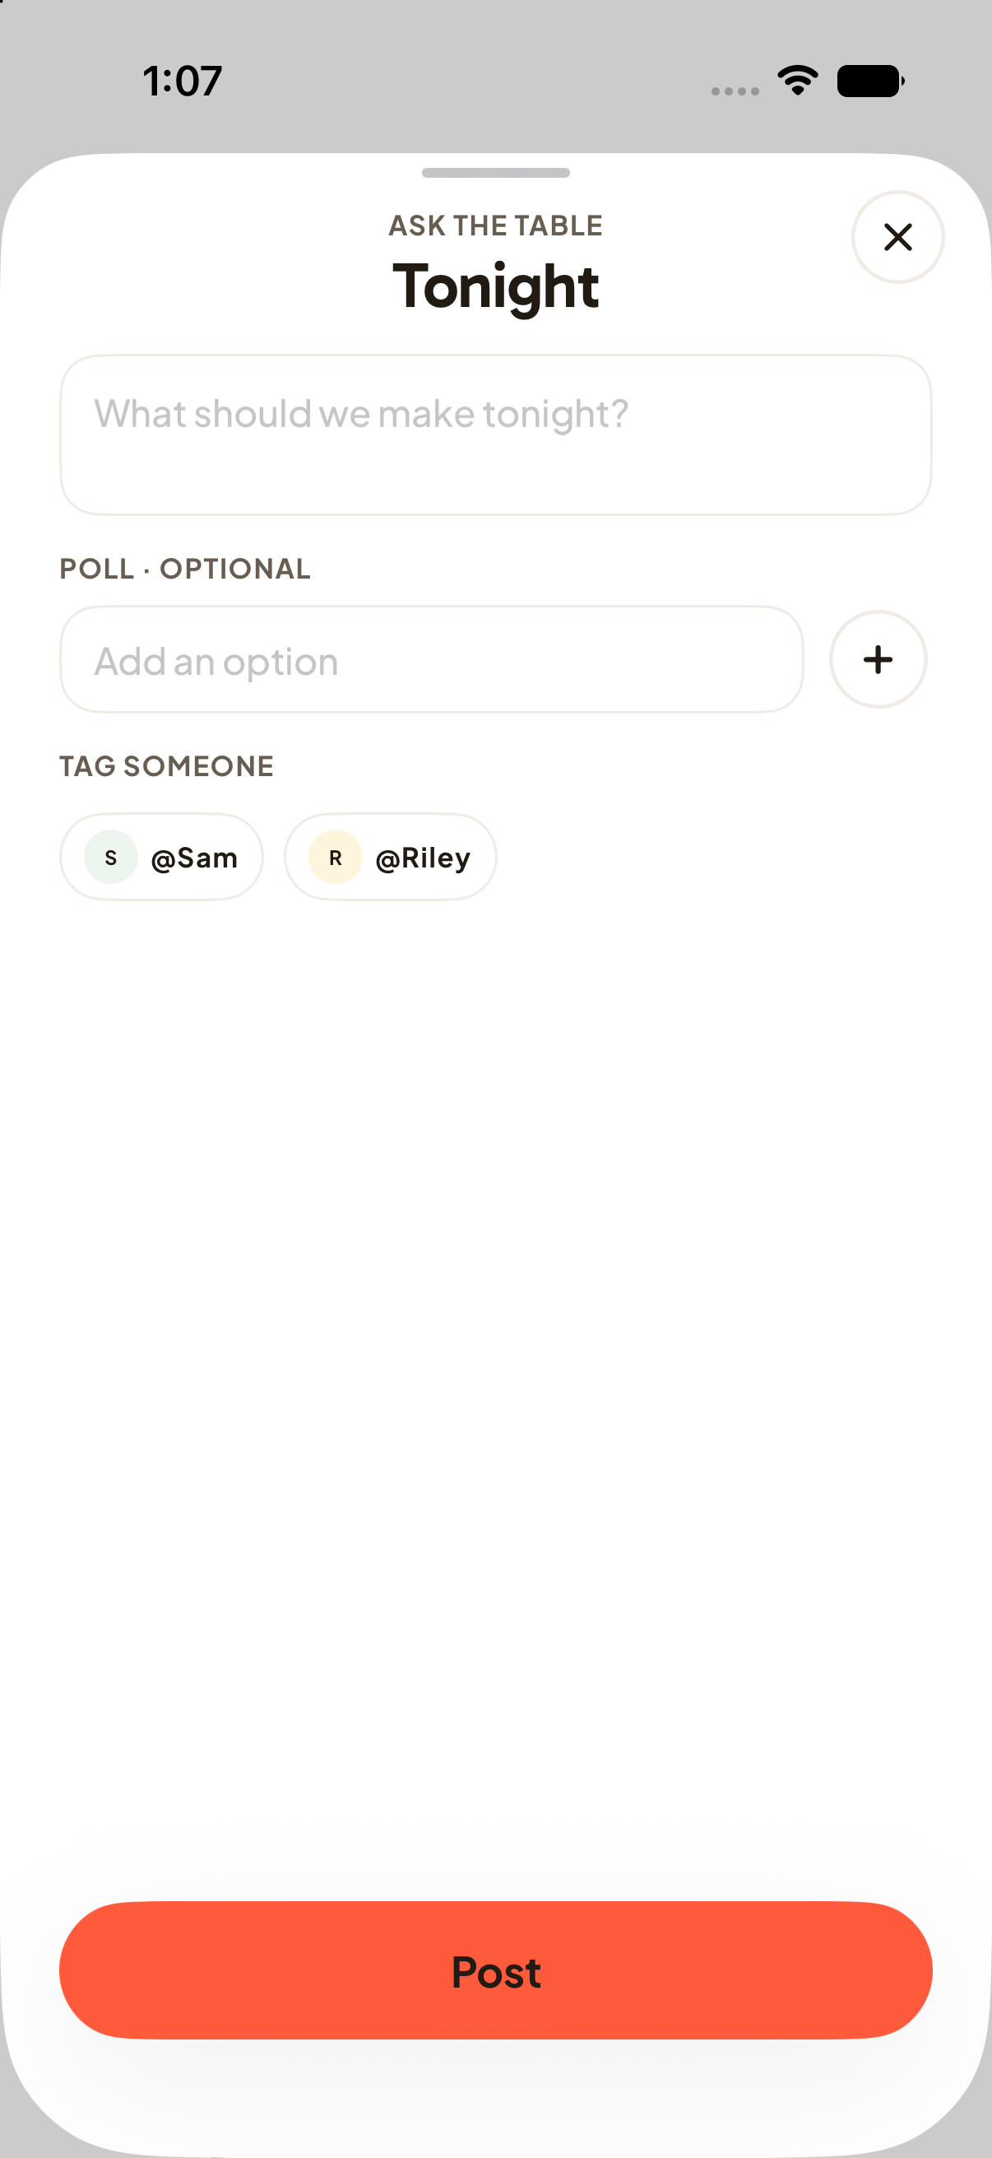  A23 | Decision  Keep / Change / Discuss  Priority  High / Medium / Low  What works  Write feedback here.  What to change  Write feedback here.  Desired result  Write feedback here.

A24 Table seats
Current working tree rendered with sample data
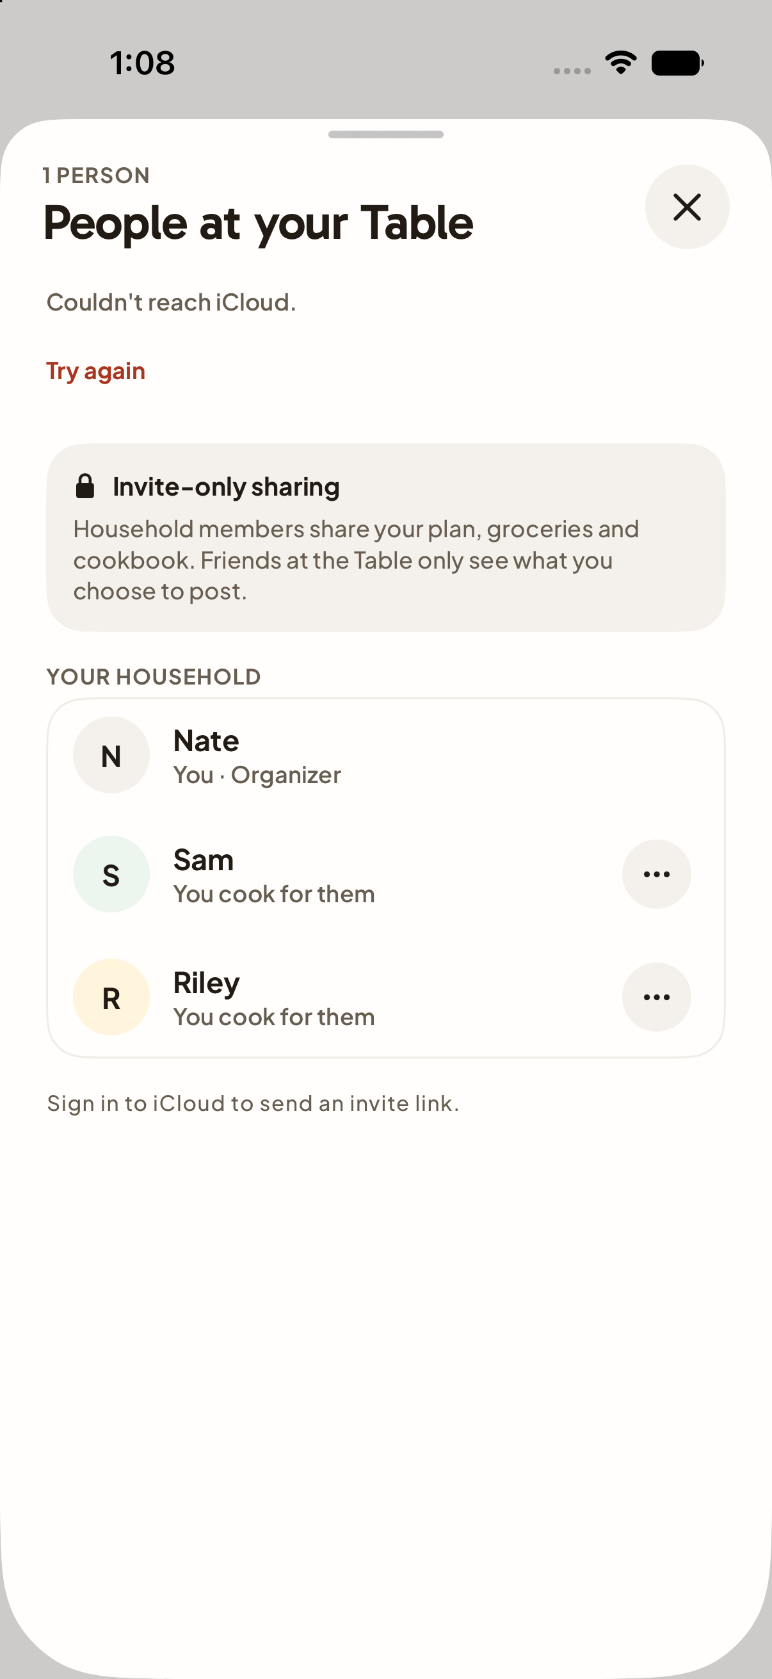  A24 | Decision  Keep / Change / Discuss  Priority  High / Medium / Low  What works  Write feedback here.  What to change  Write feedback here.  Desired result  Write feedback here.

A25 Activity
Current working tree rendered with sample data
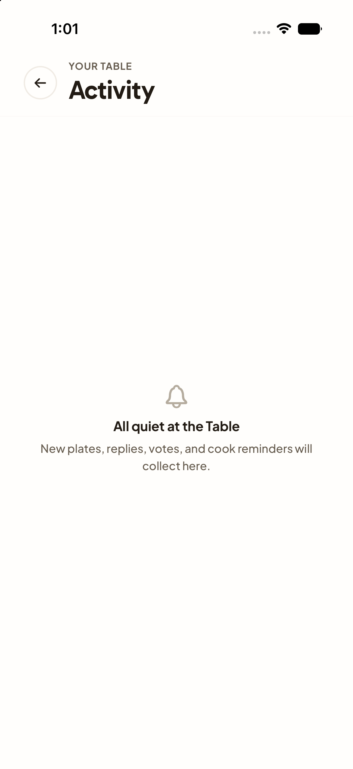  A25 | Decision  Keep / Change / Discuss  Priority  High / Medium / Low  What works  Write feedback here.  What to change  Write feedback here.  Desired result  Write feedback here.

A26 My profile
Current working tree rendered with sample data
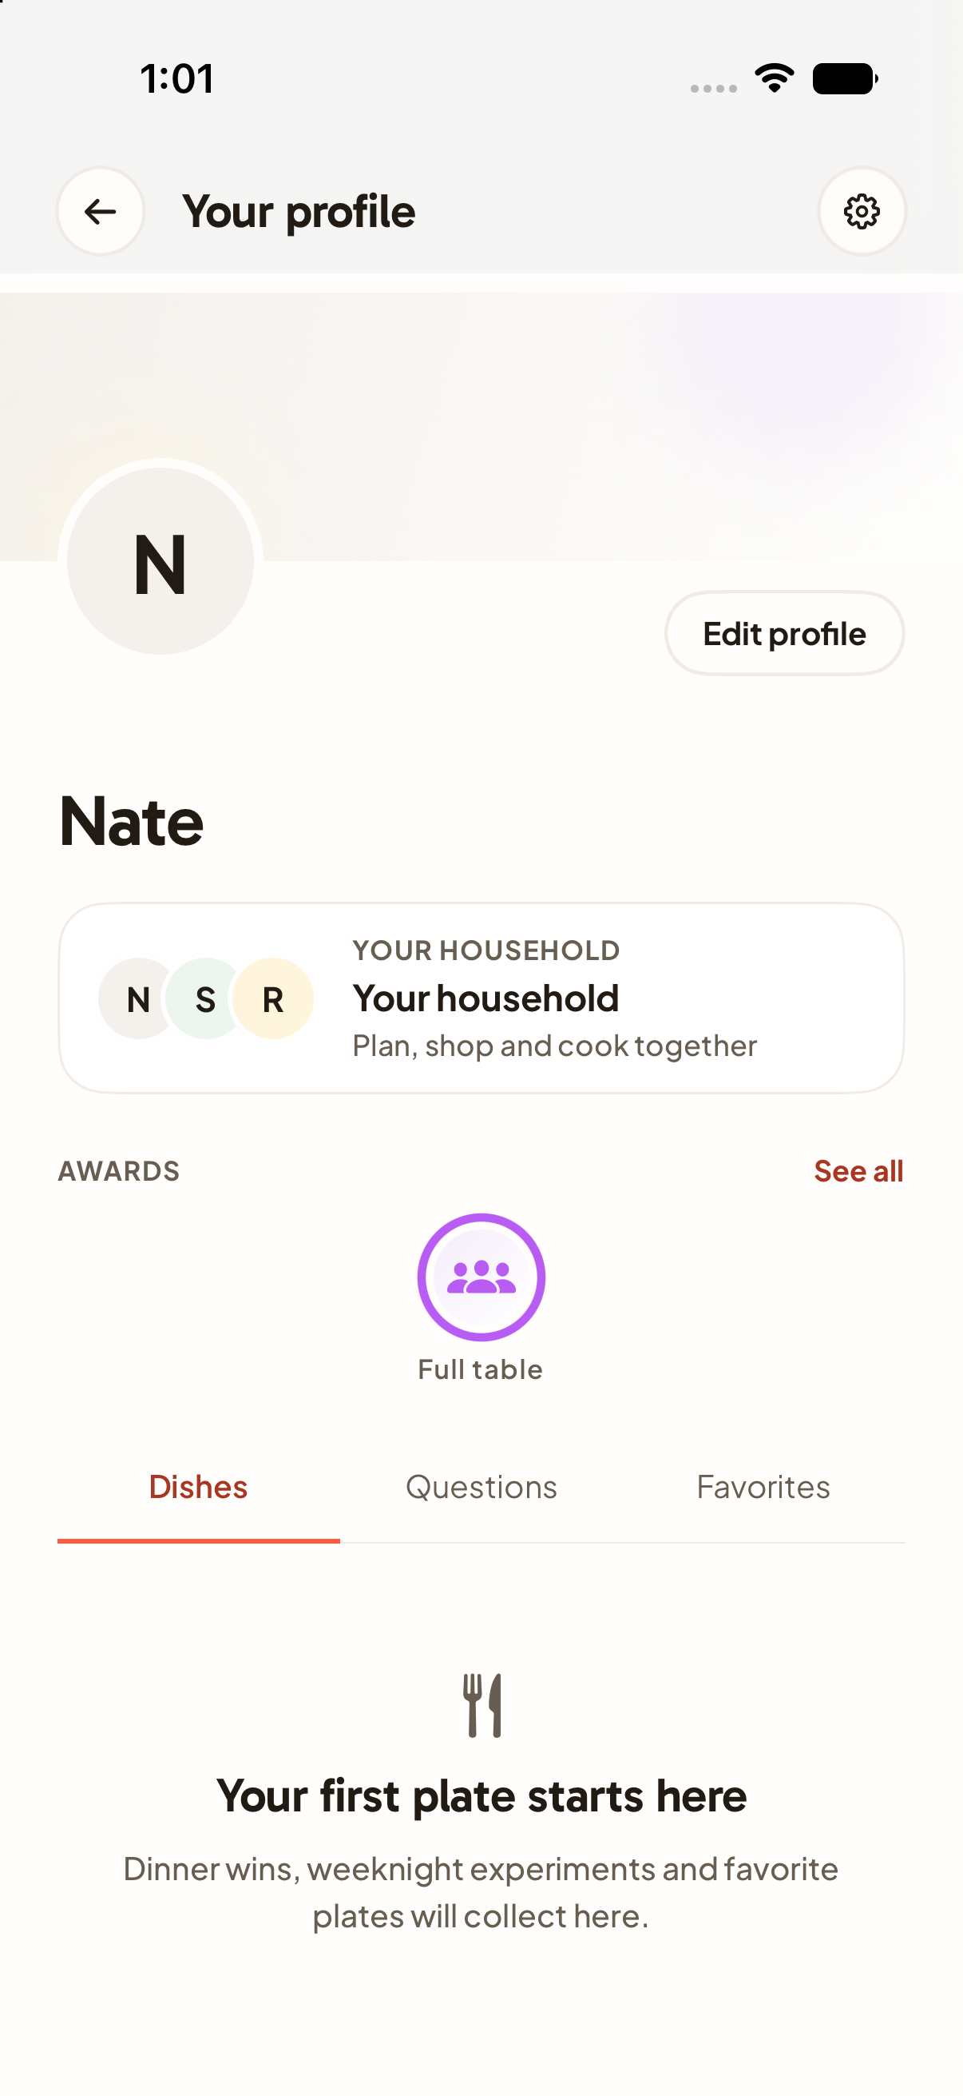  A26 | Decision  Keep / Change / Discuss  Priority  High / Medium / Low  What works  Write feedback here.  What to change  Write feedback here.  Desired result  Write feedback here.

A27 Other person profile
Current working tree rendered with sample data
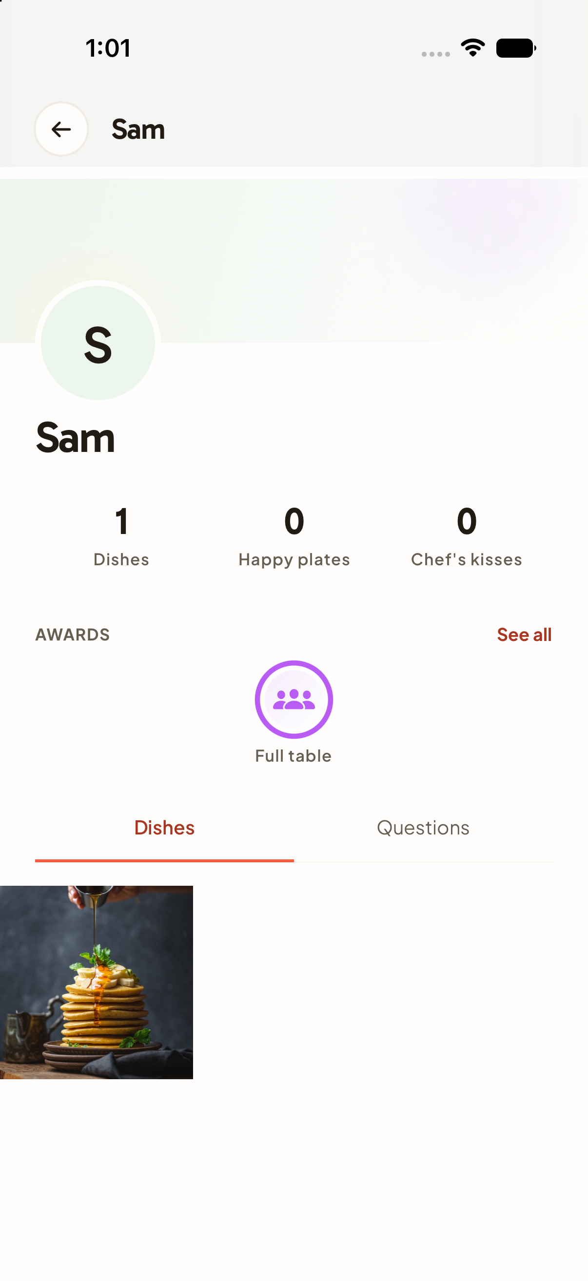  A27 | Decision  Keep / Change / Discuss  Priority  High / Medium / Low  What works  Write feedback here.  What to change  Write feedback here.  Desired result  Write feedback here.

A28 Edit profile
Current working tree rendered with sample data
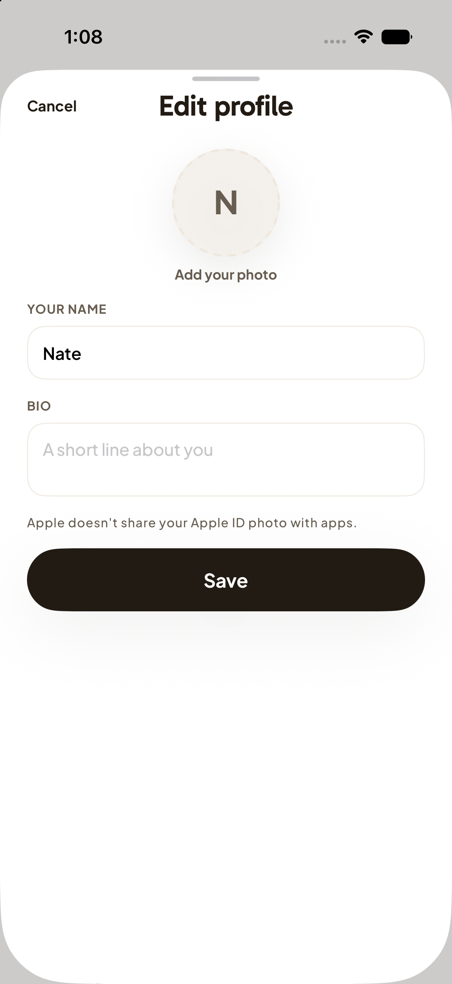  A28 | Decision  Keep / Change / Discuss  Priority  High / Medium / Low  What works  Write feedback here.  What to change  Write feedback here.  Desired result  Write feedback here.

A29 Household
Current working tree rendered with sample data
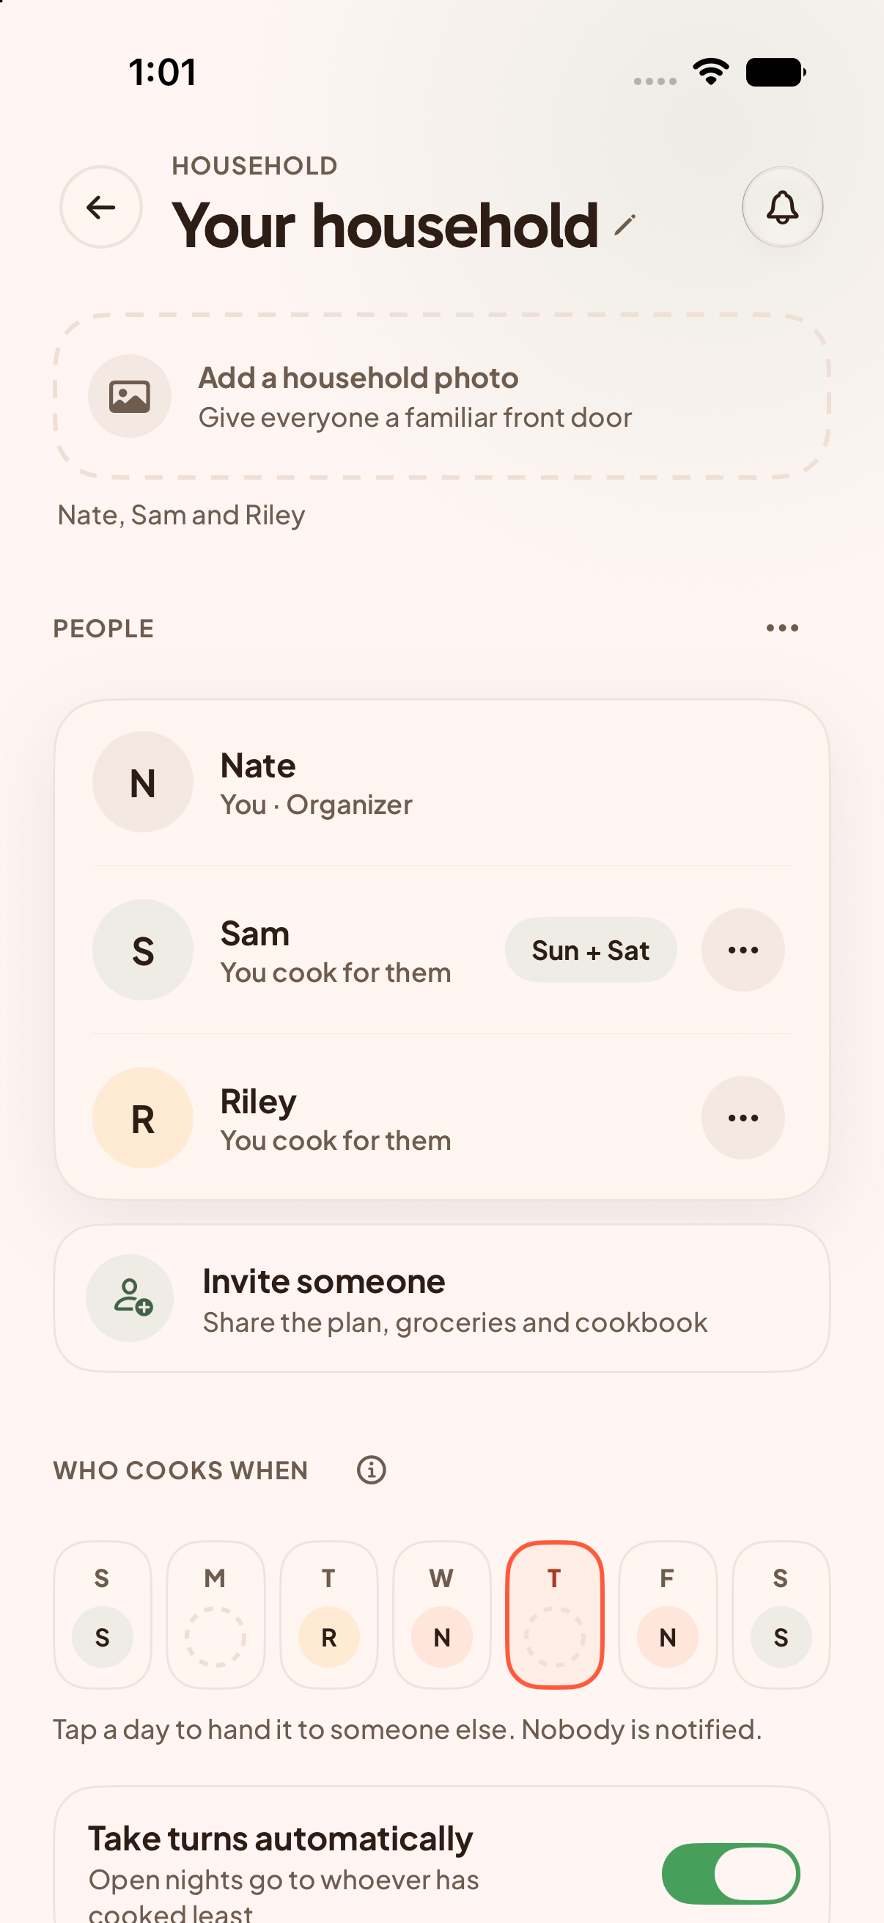  A29 | Decision  Keep / Change / Discuss  Priority  High / Medium / Low  What works  Write feedback here.  What to change  Write feedback here.  Desired result  Write feedback here.

A30 Add household member
Current working tree rendered with sample data
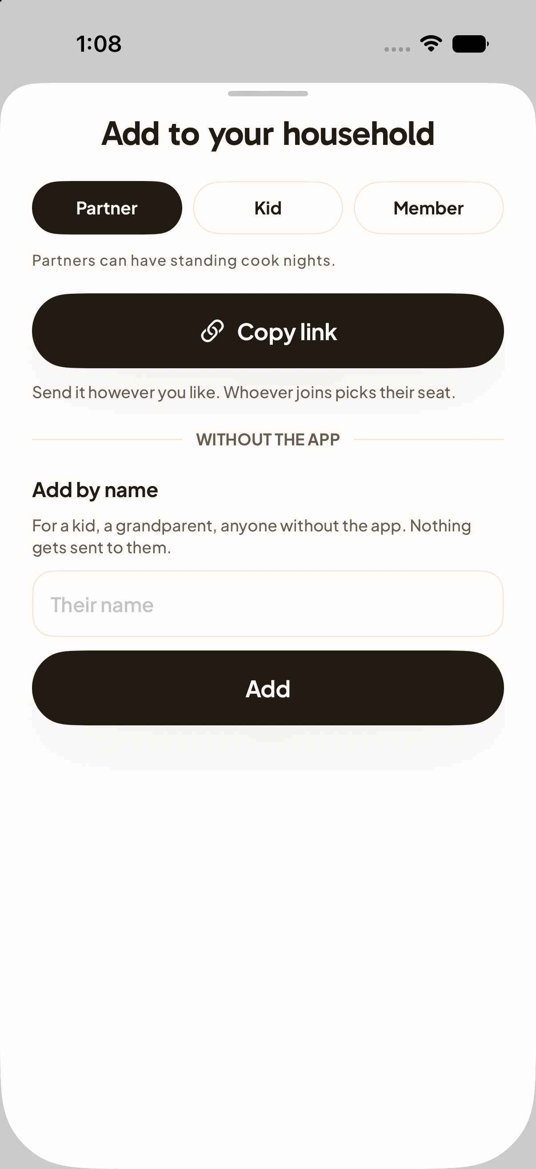  A30 | Decision  Keep / Change / Discuss  Priority  High / Medium / Low  What works  Write feedback here.  What to change  Write feedback here.  Desired result  Write feedback here.

A31 Household statistics
Current working tree rendered with sample data
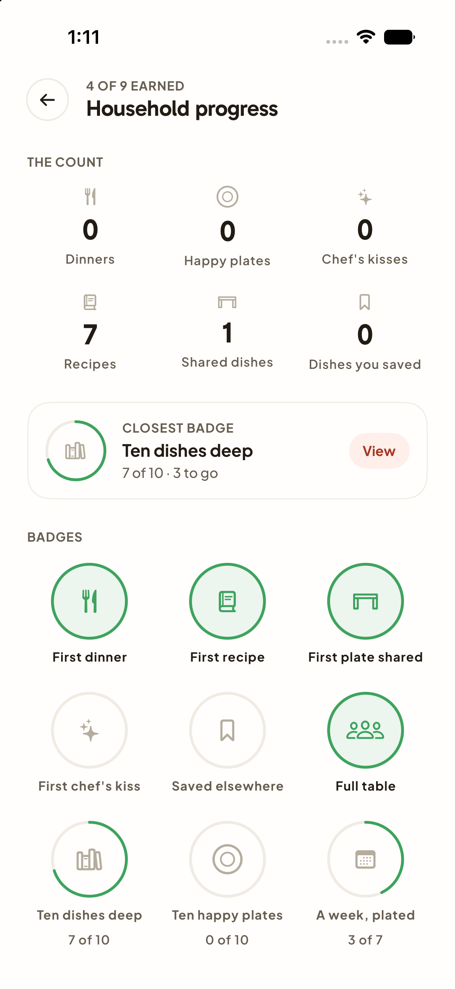  A31 | Decision  Keep / Change / Discuss  Priority  High / Medium / Low  What works  Write feedback here.  What to change  Write feedback here.  Desired result  Write feedback here.

A32 Awards
Current working tree rendered with sample data
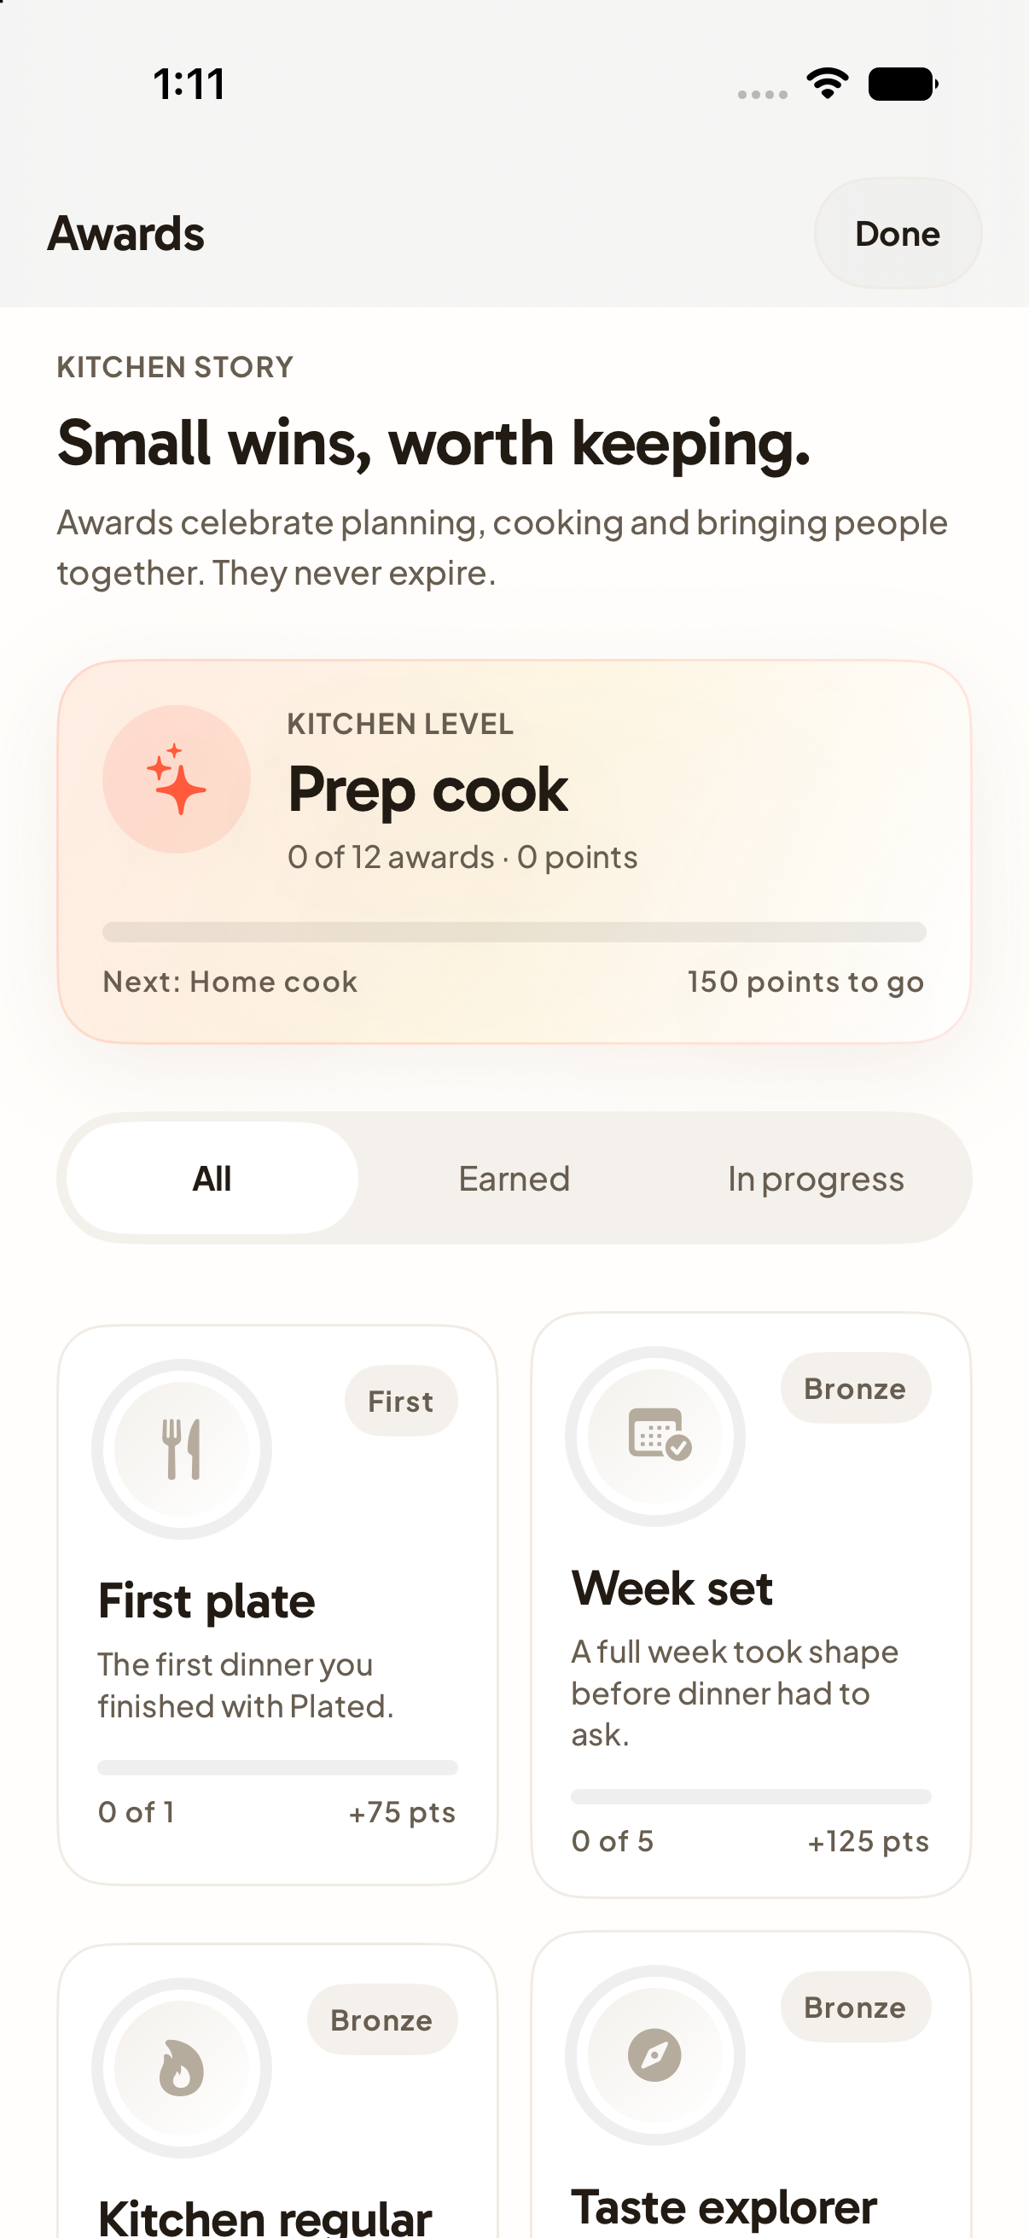  A32 | Decision  Keep / Change / Discuss  Priority  High / Medium / Low  What works  Write feedback here.  What to change  Write feedback here.  Desired result  Write feedback here.

A33 Settings
Current working tree rendered with sample data
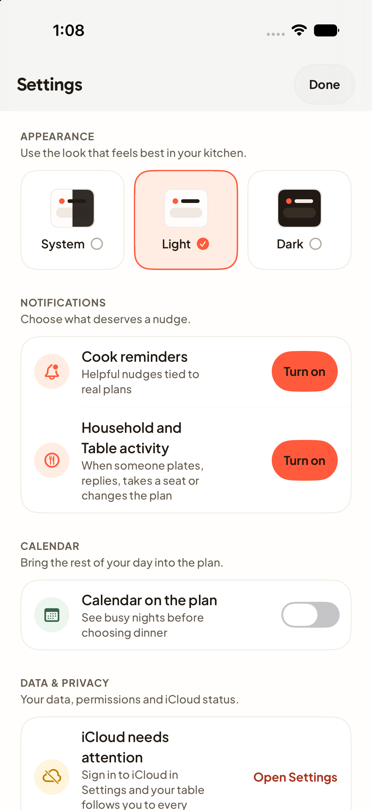  A33 | Decision  Keep / Change / Discuss  Priority  High / Medium / Low  What works  Write feedback here.  What to change  Write feedback here.  Desired result  Write feedback here.

A34 Gathering
Current working tree rendered with sample data
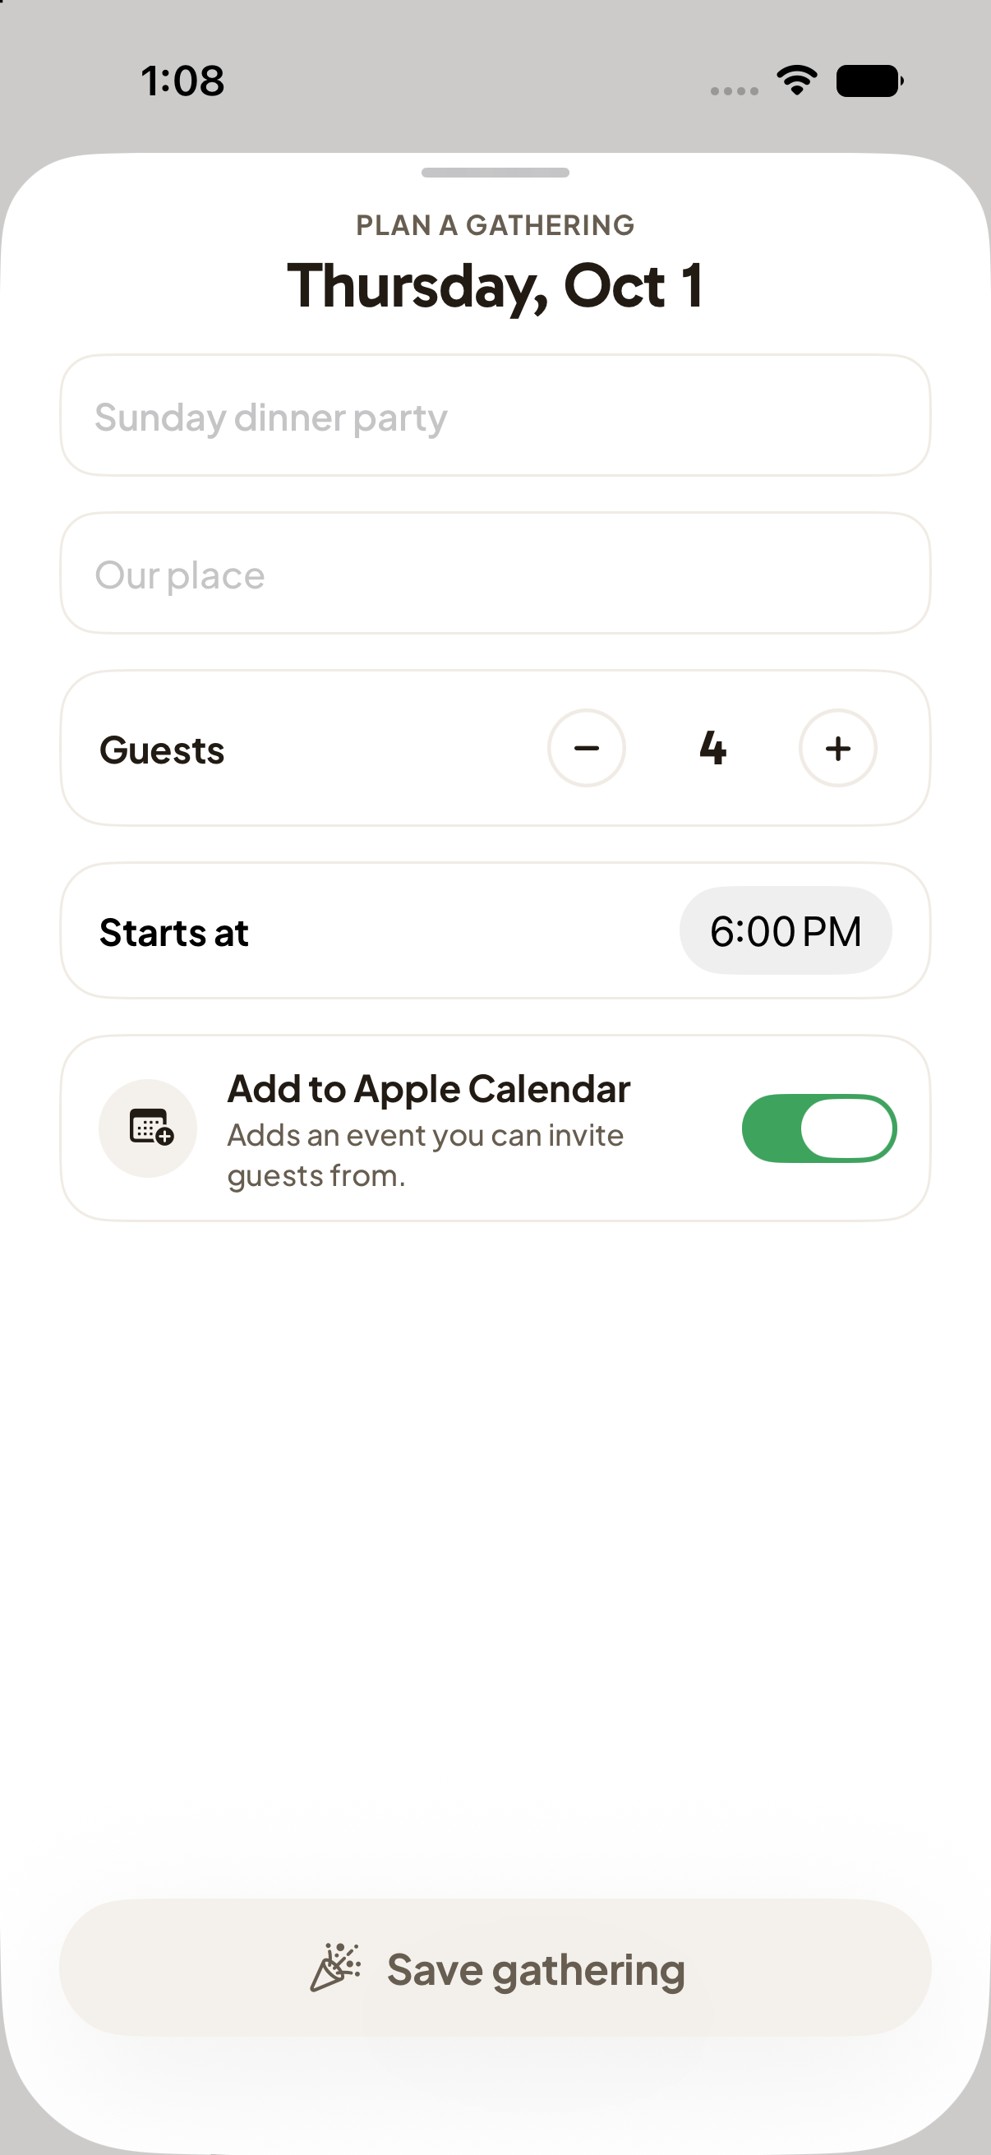  A34 | Decision  Keep / Change / Discuss  Priority  High / Medium / Low  What works  Write feedback here.  What to change  Write feedback here.  Desired result  Write feedback here.

A35 Join household failure
Invitation error state rendered with sample text
  A35 | Decision  Keep / Change / Discuss  Priority  High / Medium / Low  What works  Write feedback here.  What to change  Write feedback here.  Desired result  Write feedback here.

A36 Create menu
Current working tree rendered with sample data
  A36 | Decision  Keep / Change / Discuss  Priority  High / Medium / Low  What works  Write feedback here.  What to change  Write feedback here.  Desired result  Write feedback here.

A37 Sign in
Current working tree rendered with sample data
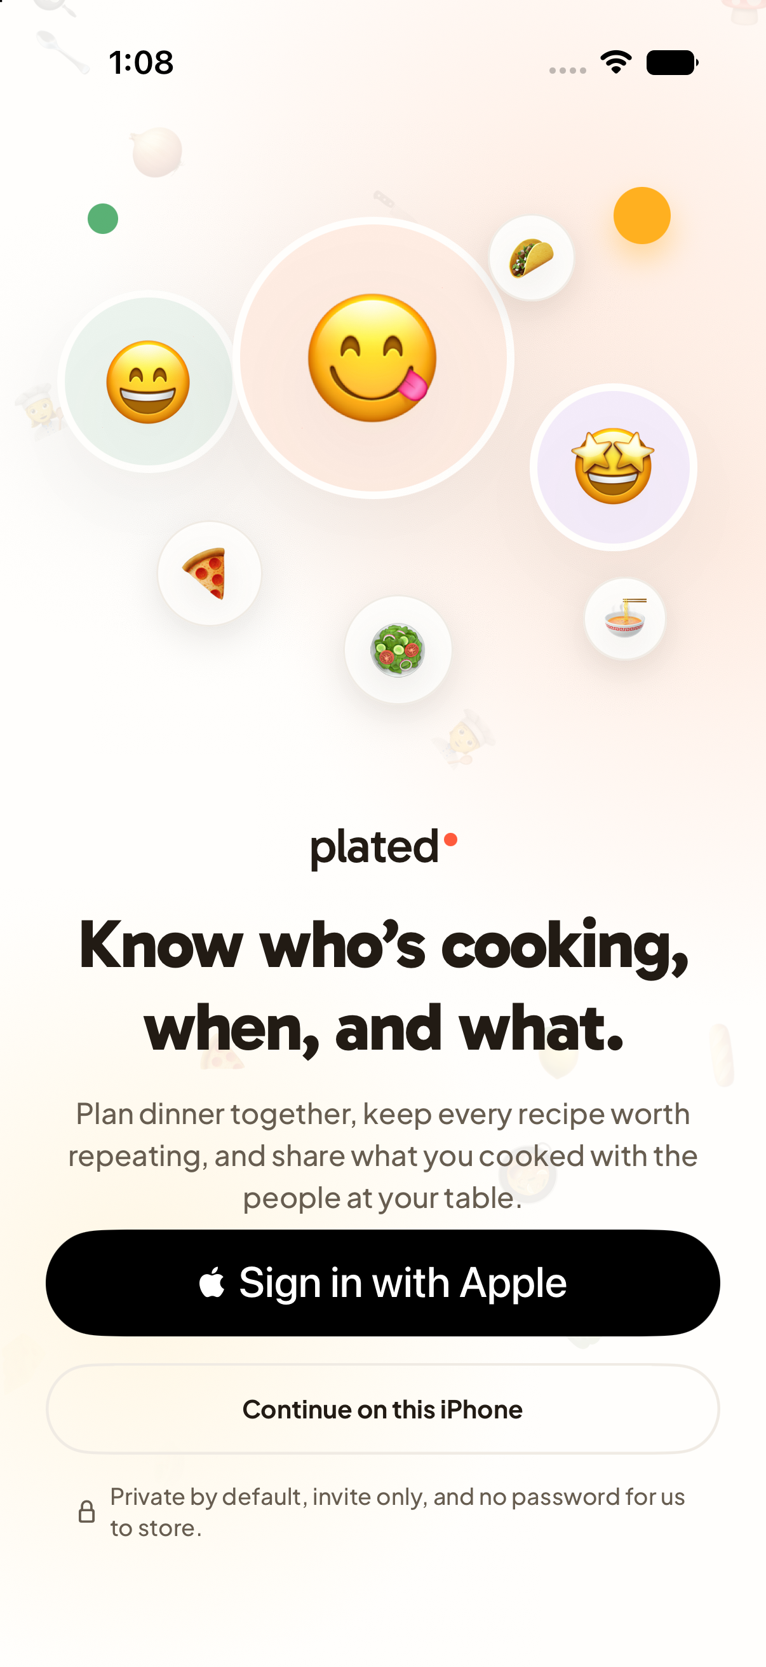  A37 | Decision  Keep / Change / Discuss  Priority  High / Medium / Low  What works  Write feedback here.  What to change  Write feedback here.  Desired result  Write feedback here.

A38 Profile setup
Current working tree rendered with sample data
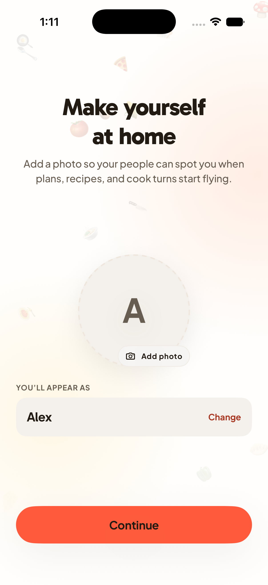  A38 | Decision  Keep / Change / Discuss  Priority  High / Medium / Low  What works  Write feedback here.  What to change  Write feedback here.  Desired result  Write feedback here.

A39 Contacts onboarding
Current working tree rendered with sample data
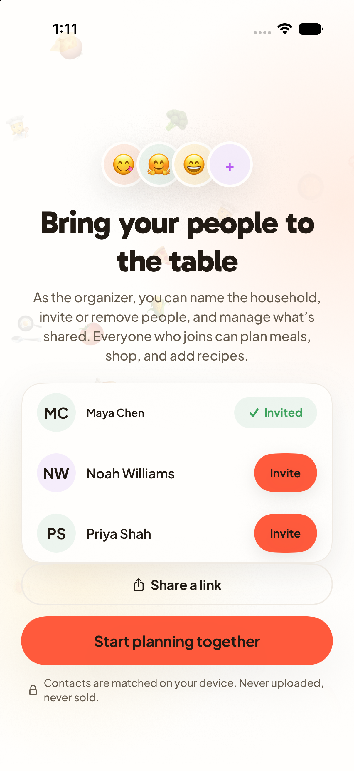  A39 | Decision  Keep / Change / Discuss  Priority  High / Medium / Low  What works  Write feedback here.  What to change  Write feedback here.  Desired result  Write feedback here.

A40 Tour tonight
Current working tree rendered with sample data
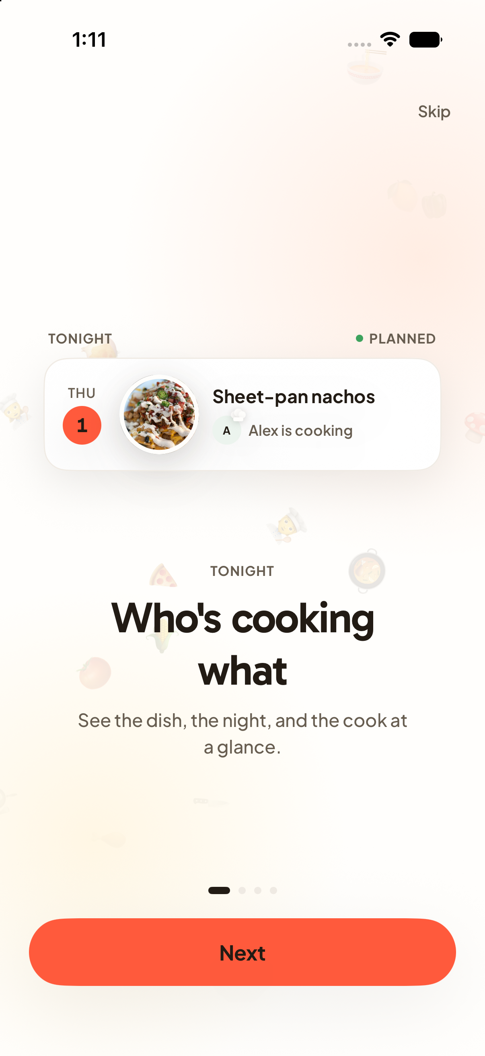  A40 | Decision  Keep / Change / Discuss  Priority  High / Medium / Low  What works  Write feedback here.  What to change  Write feedback here.  Desired result  Write feedback here.

A41 Tour plan ahead
Current working tree rendered with sample data
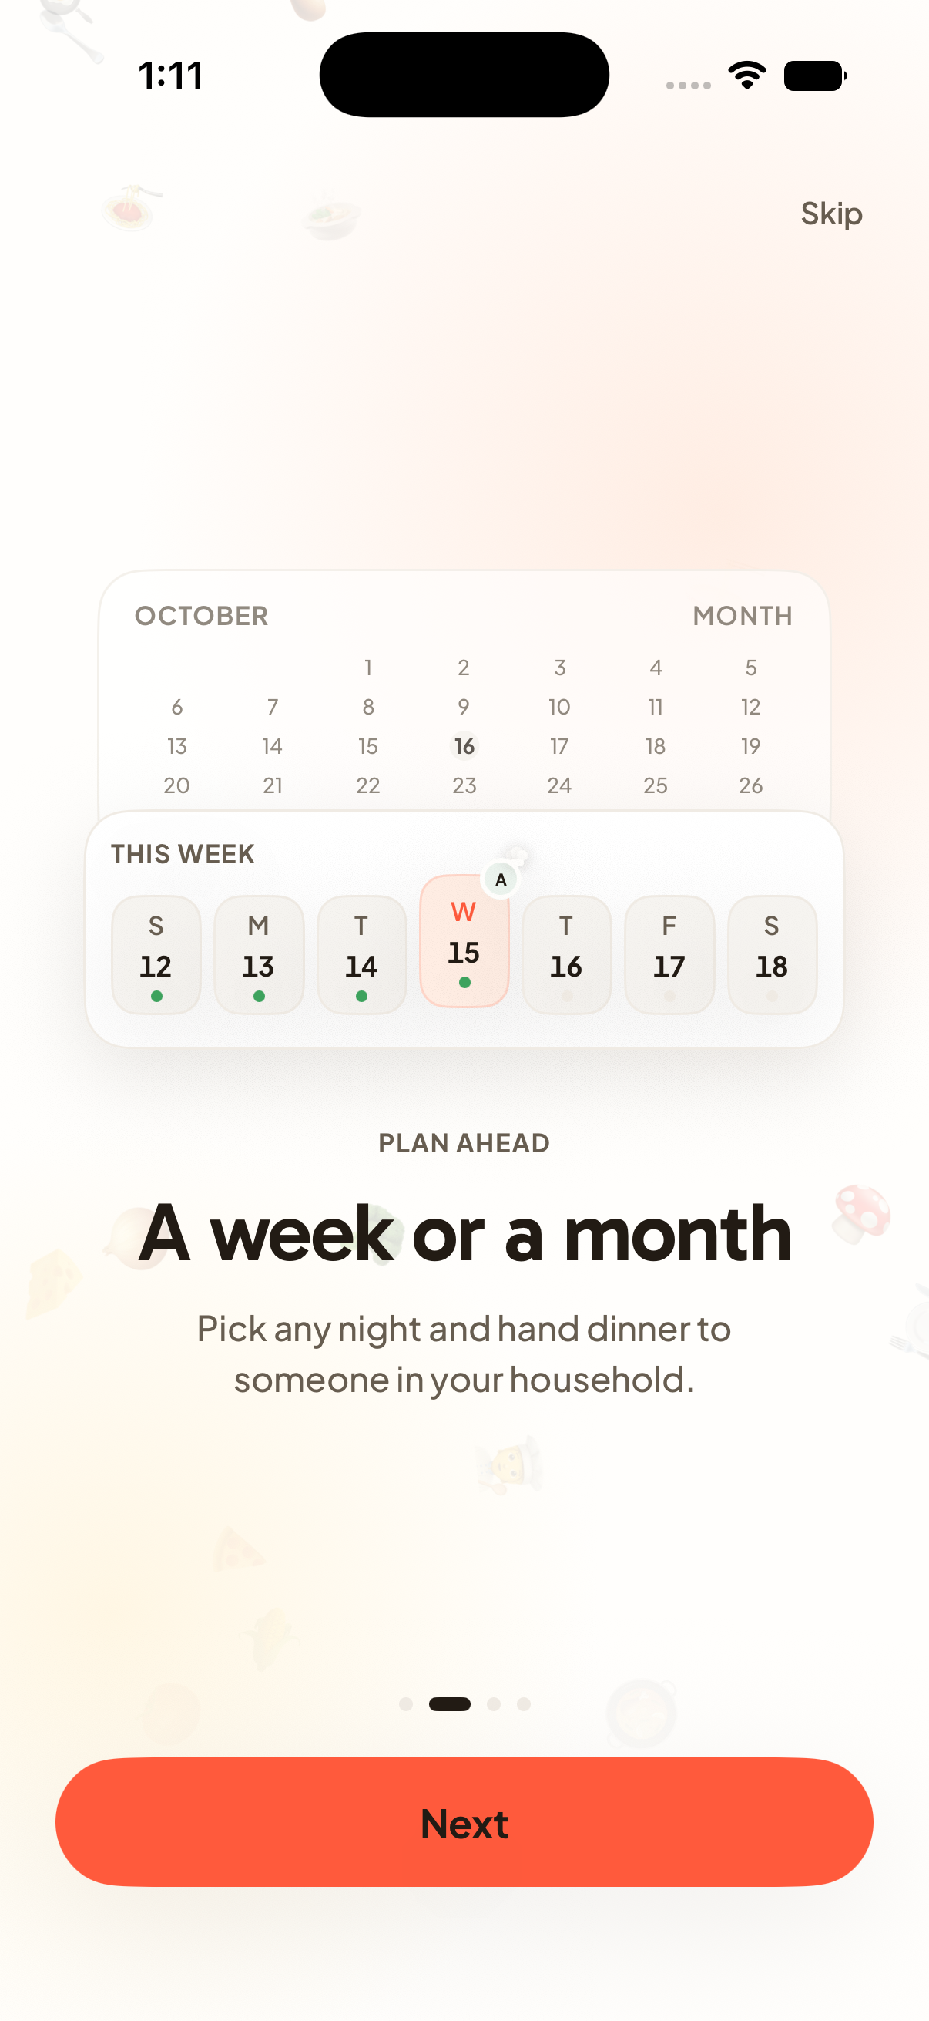  A41 | Decision  Keep / Change / Discuss  Priority  High / Medium / Low  What works  Write feedback here.  What to change  Write feedback here.  Desired result  Write feedback here.

A42 Tour recipes
Current working tree rendered with sample data
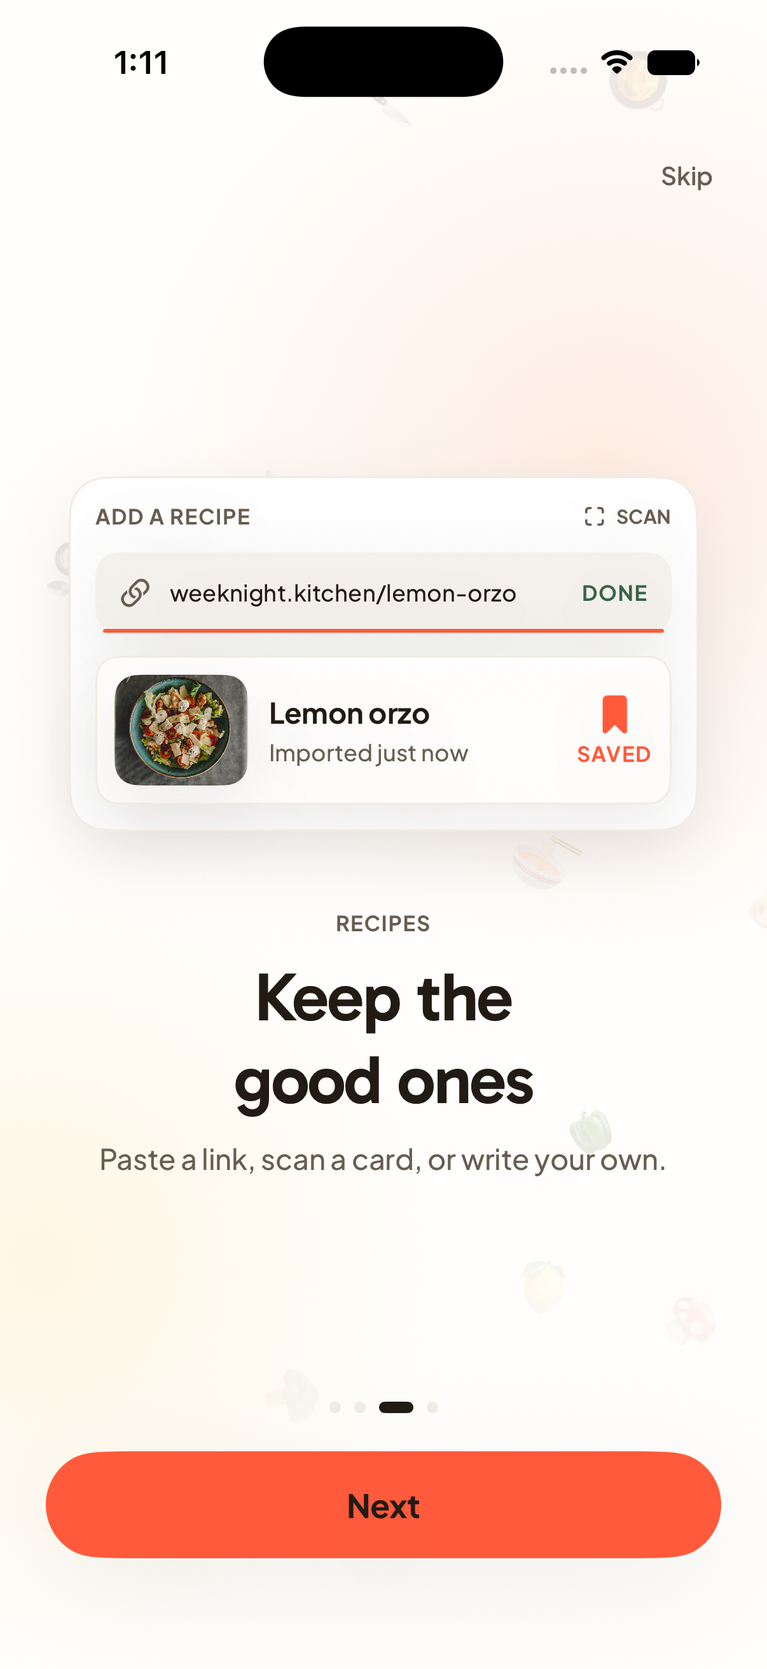  A42 | Decision  Keep / Change / Discuss  Priority  High / Medium / Low  What works  Write feedback here.  What to change  Write feedback here.  Desired result  Write feedback here.

A43 Tour Table
Current working tree rendered with sample data
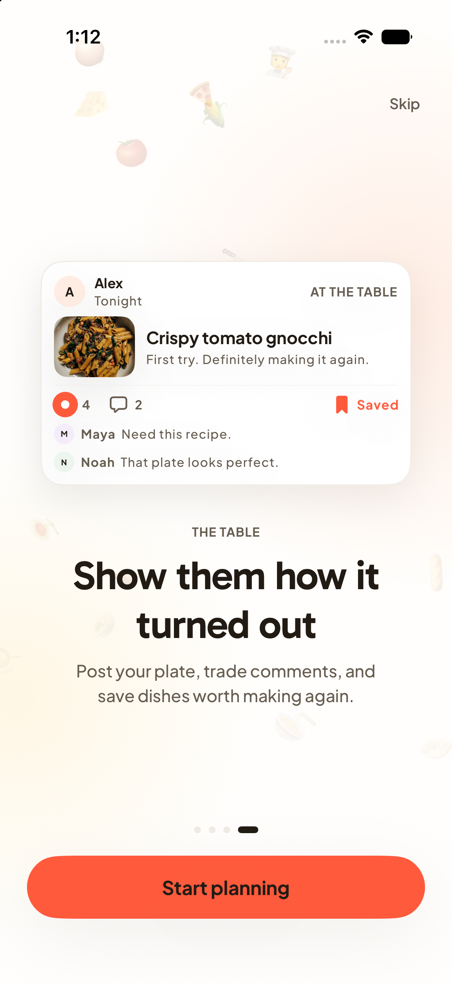  A43 | Decision  Keep / Change / Discuss  Priority  High / Medium / Low  What works  Write feedback here.  What to change  Write feedback here.  Desired result  Write feedback here.

A44 Launch opener
Current working tree rendered with sample data
  A44 | Decision  Keep / Change / Discuss  Priority  High / Medium / Low  What works  Write feedback here.  What to change  Write feedback here.  Desired result  Write feedback here.

A45 Cooking ingredients
Current working tree rendered with sample data
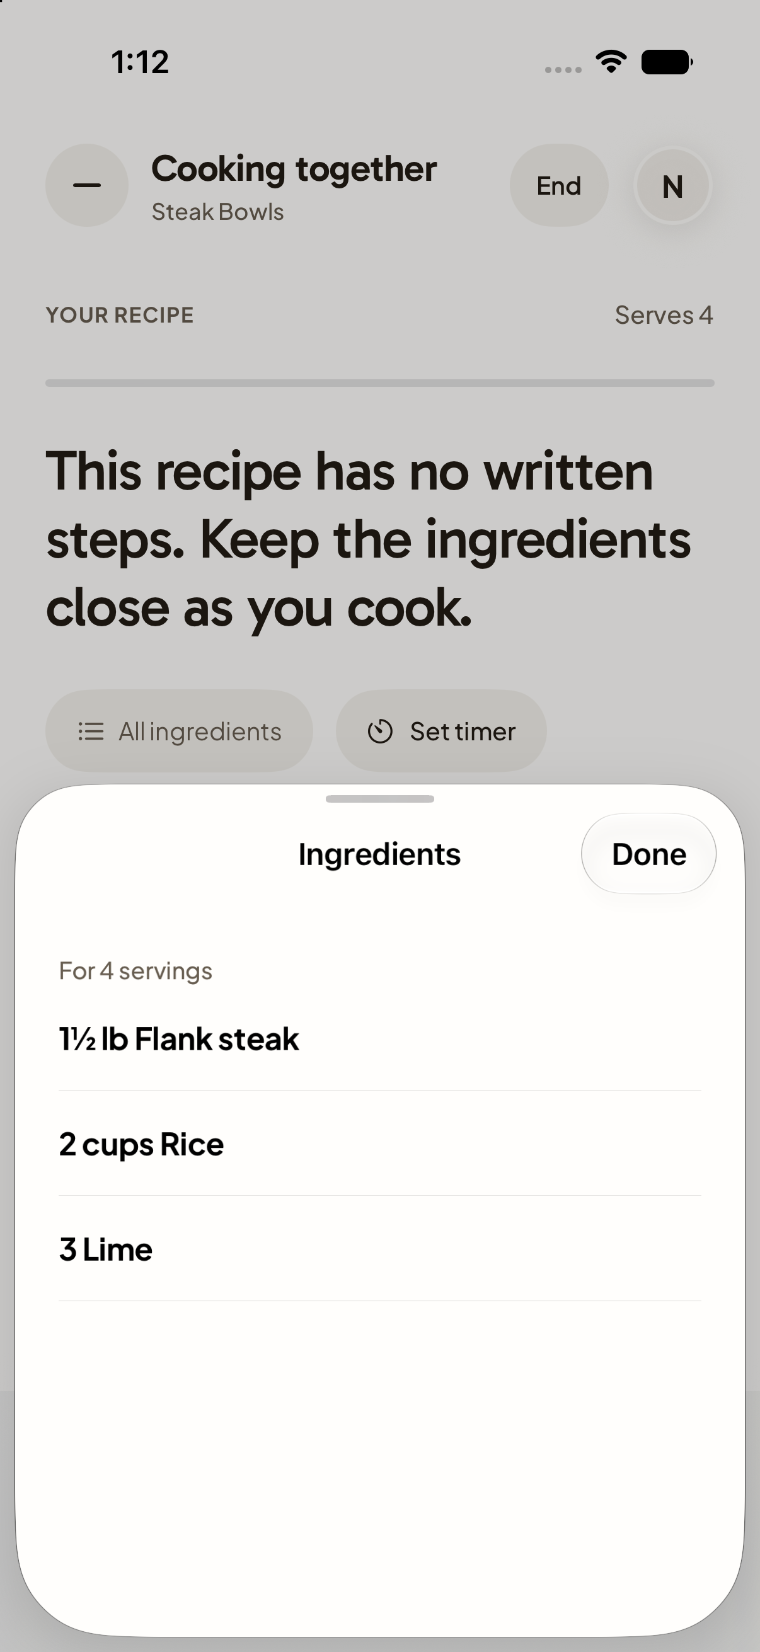  A45 | Decision  Keep / Change / Discuss  Priority  High / Medium / Low  What works  Write feedback here.  What to change  Write feedback here.  Desired result  Write feedback here.

A46 Cooking complete
Current working tree rendered with sample data
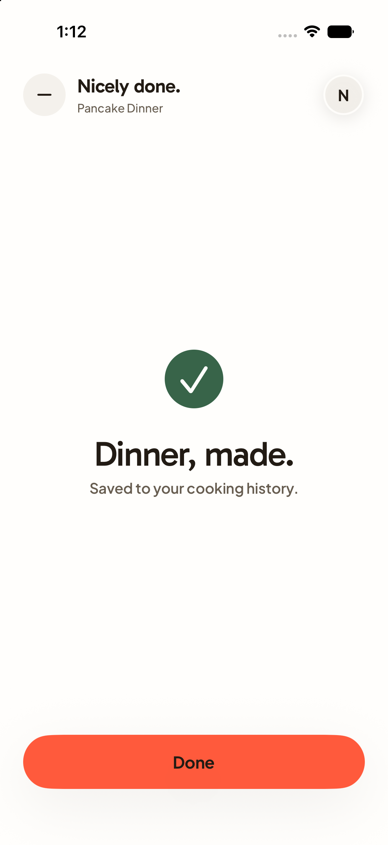  A46 | Decision  Keep / Change / Discuss  Priority  High / Medium / Low  What works  Write feedback here.  What to change  Write feedback here.  Desired result  Write feedback here.

A47 Groceries by meal
Current working tree rendered with sample data
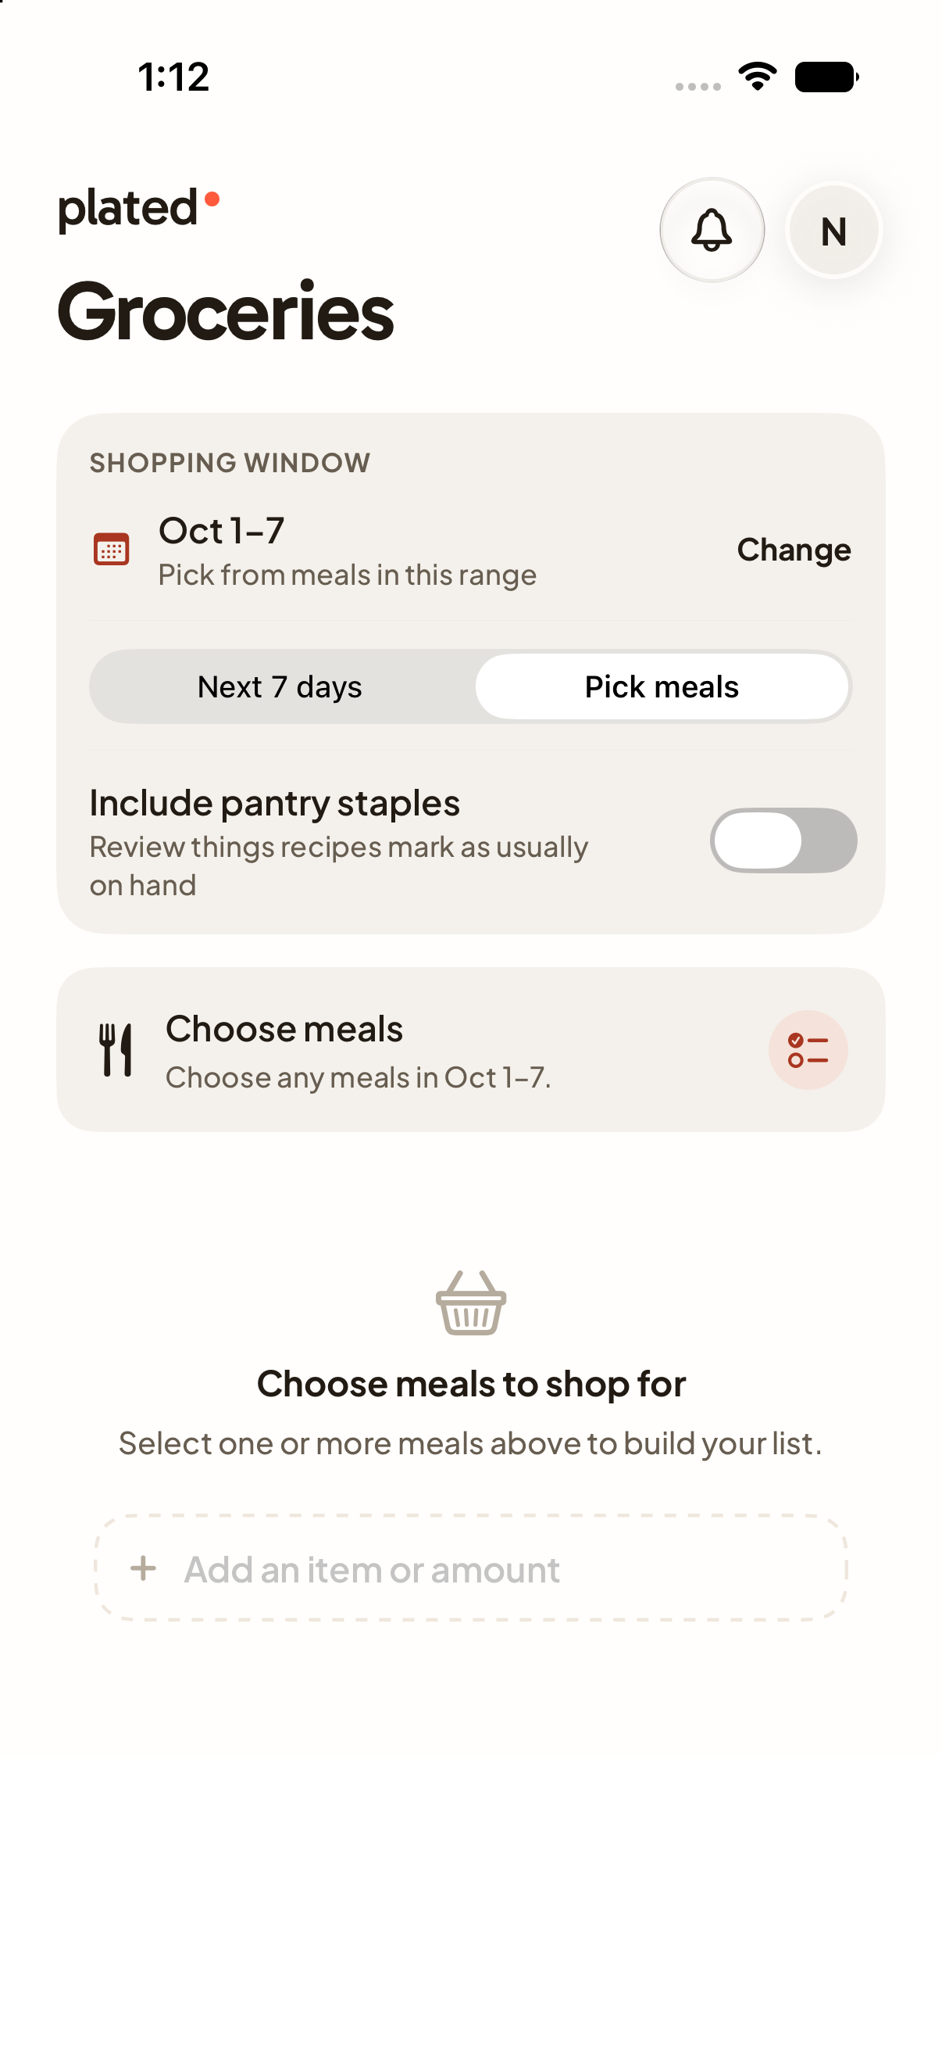  A47 | Decision  Keep / Change / Discuss  Priority  High / Medium / Low  What works  Write feedback here.  What to change  Write feedback here.  Desired result  Write feedback here.

A48 Grocery meal picker
Current working tree rendered with sample data
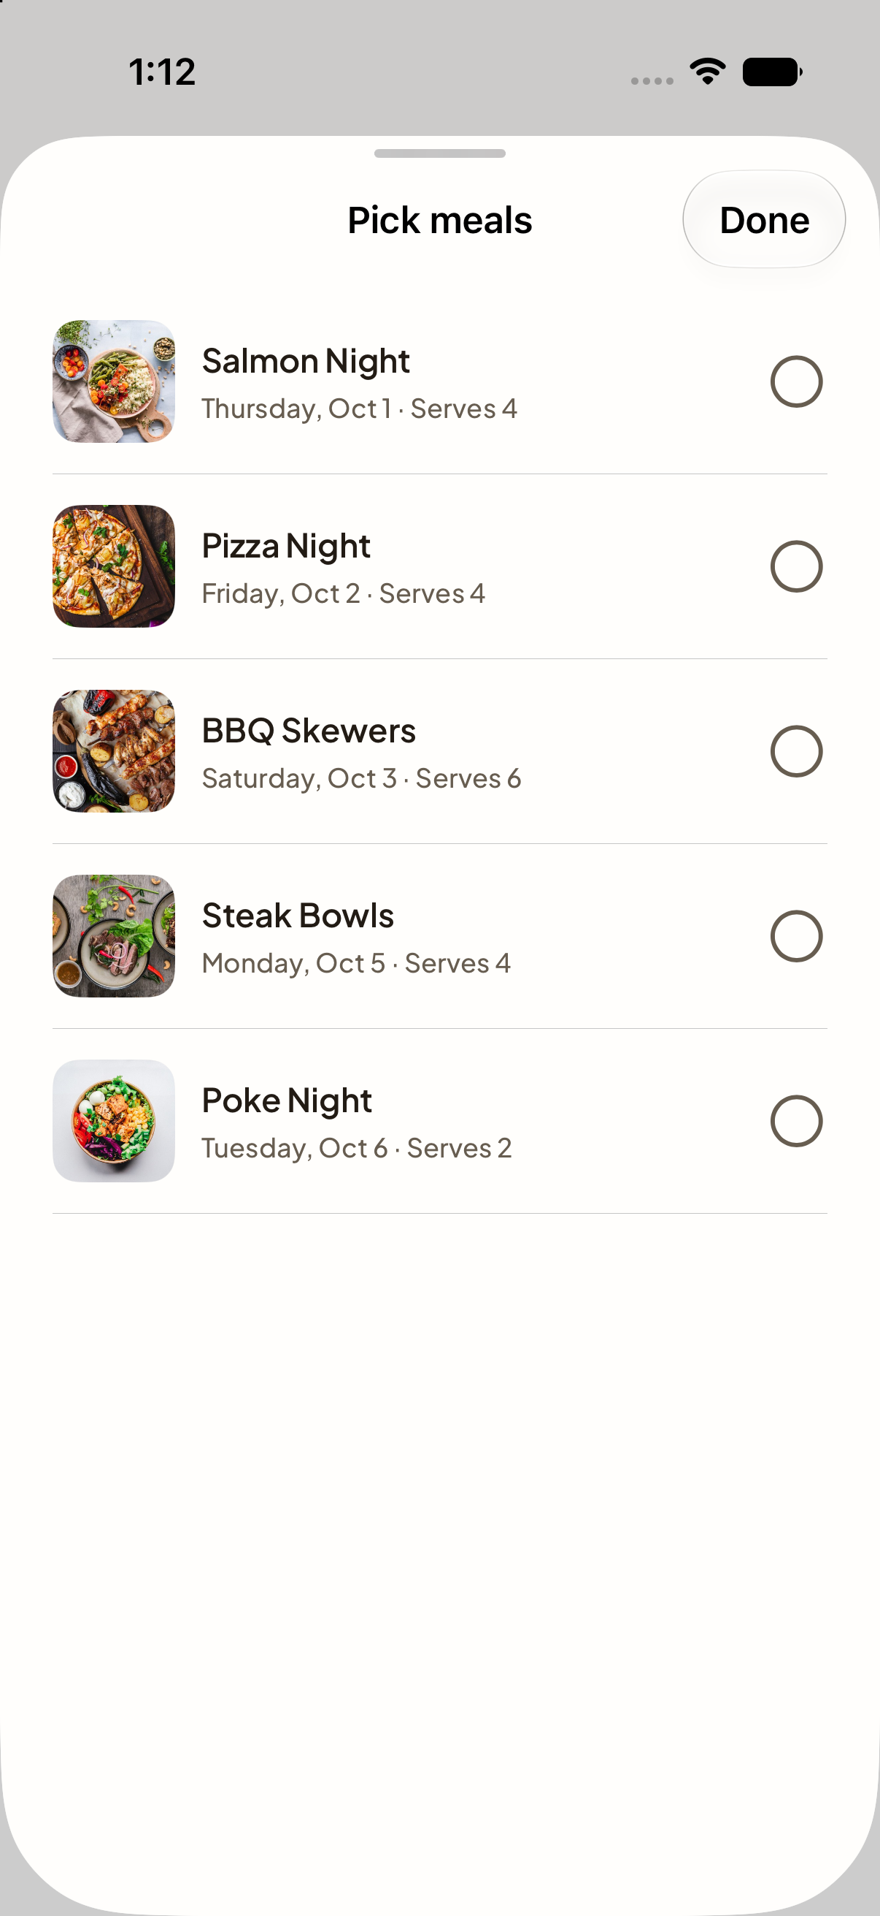  A48 | Decision  Keep / Change / Discuss  Priority  High / Medium / Low  What works  Write feedback here.  What to change  Write feedback here.  Desired result  Write feedback here.

A49 Grocery shopping options
Current working tree rendered with sample data
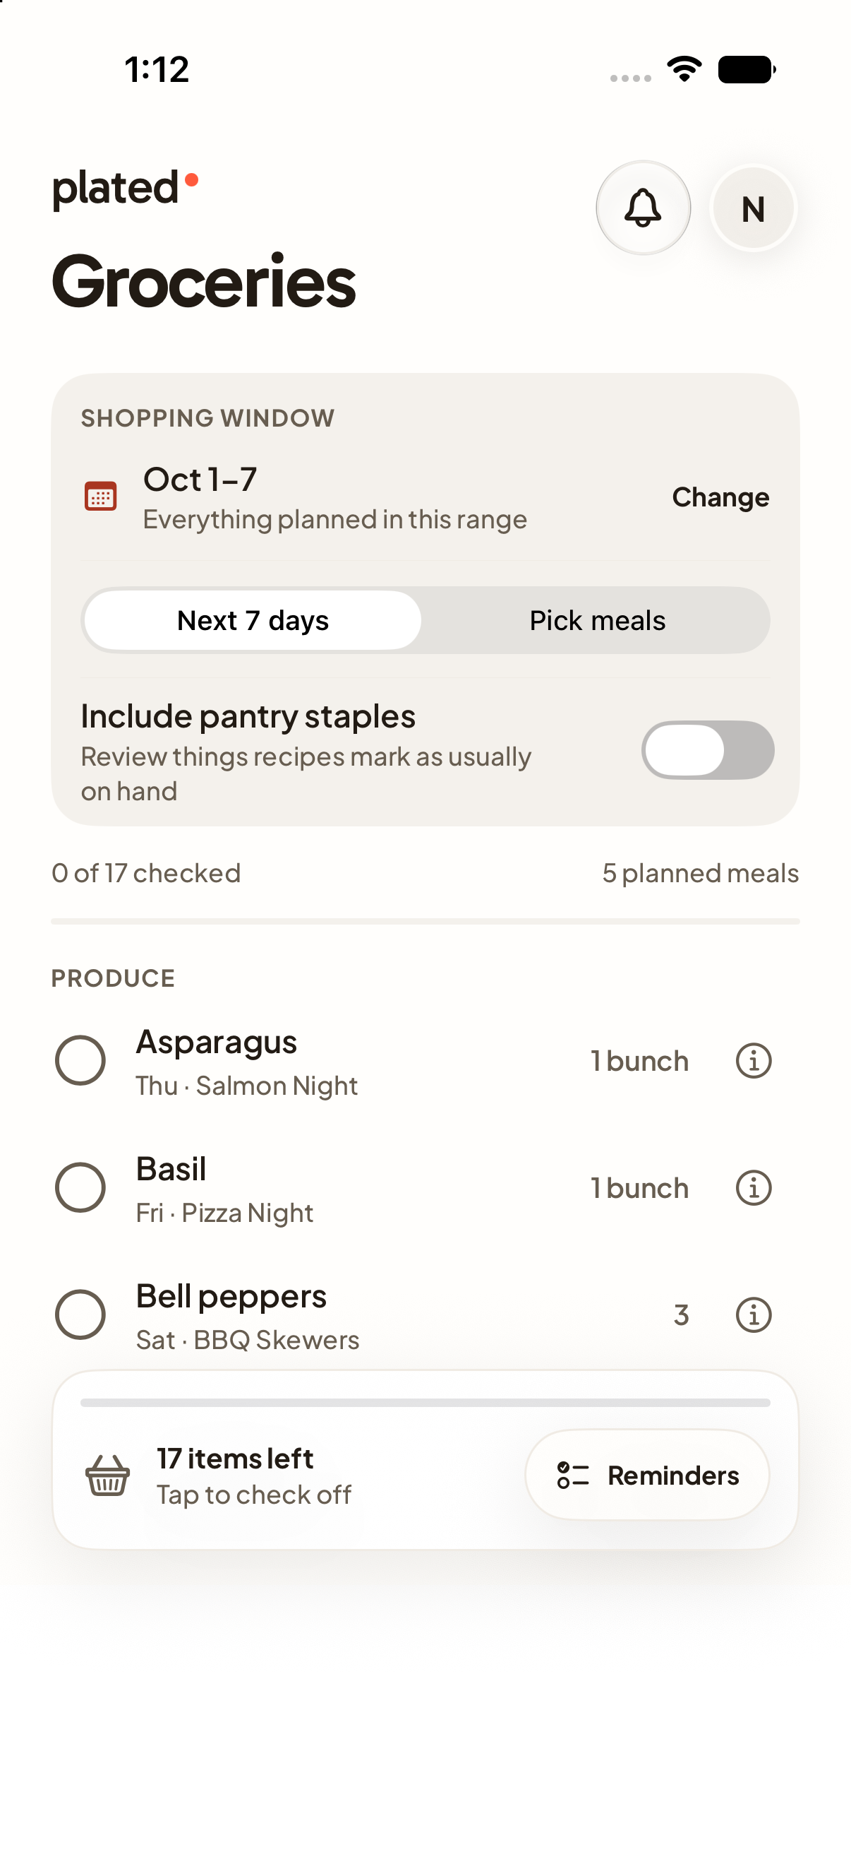  A49 | Decision  Keep / Change / Discuss  Priority  High / Medium / Low  What works  Write feedback here.  What to change  Write feedback here.  Desired result  Write feedback here.

A50 Post a question
Current working tree rendered with sample data
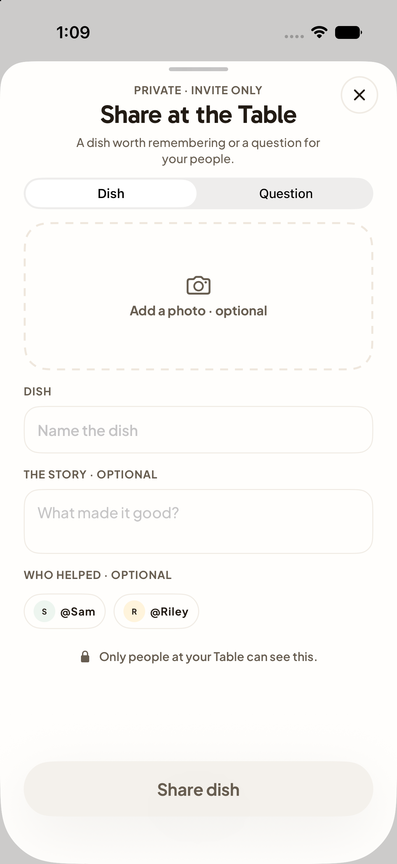  A50 | Decision  Keep / Change / Discuss  Priority  High / Medium / Low  What works  Write feedback here.  What to change  Write feedback here.  Desired result  Write feedback here.

A51 Award detail
Current working tree rendered with sample data
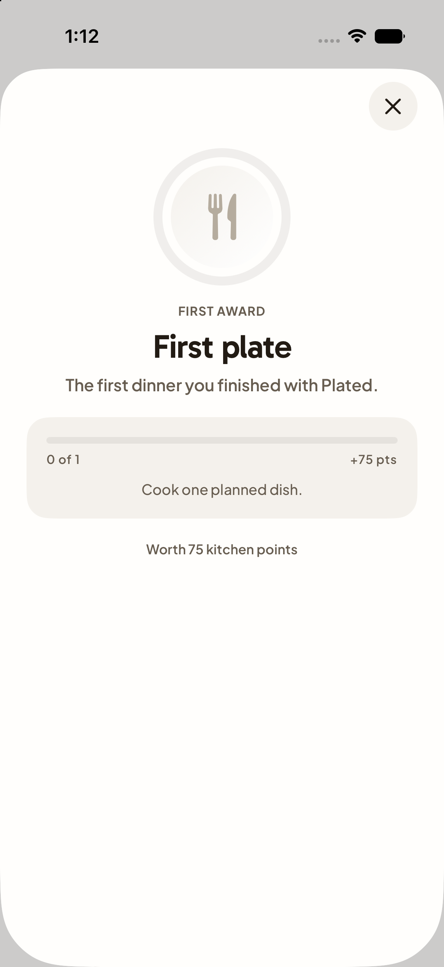  A51 | Decision  Keep / Change / Discuss  Priority  High / Medium / Low  What works  Write feedback here.  What to change  Write feedback here.  Desired result  Write feedback here.

A52 Apple sign in fallback
Current working tree rendered with sample data
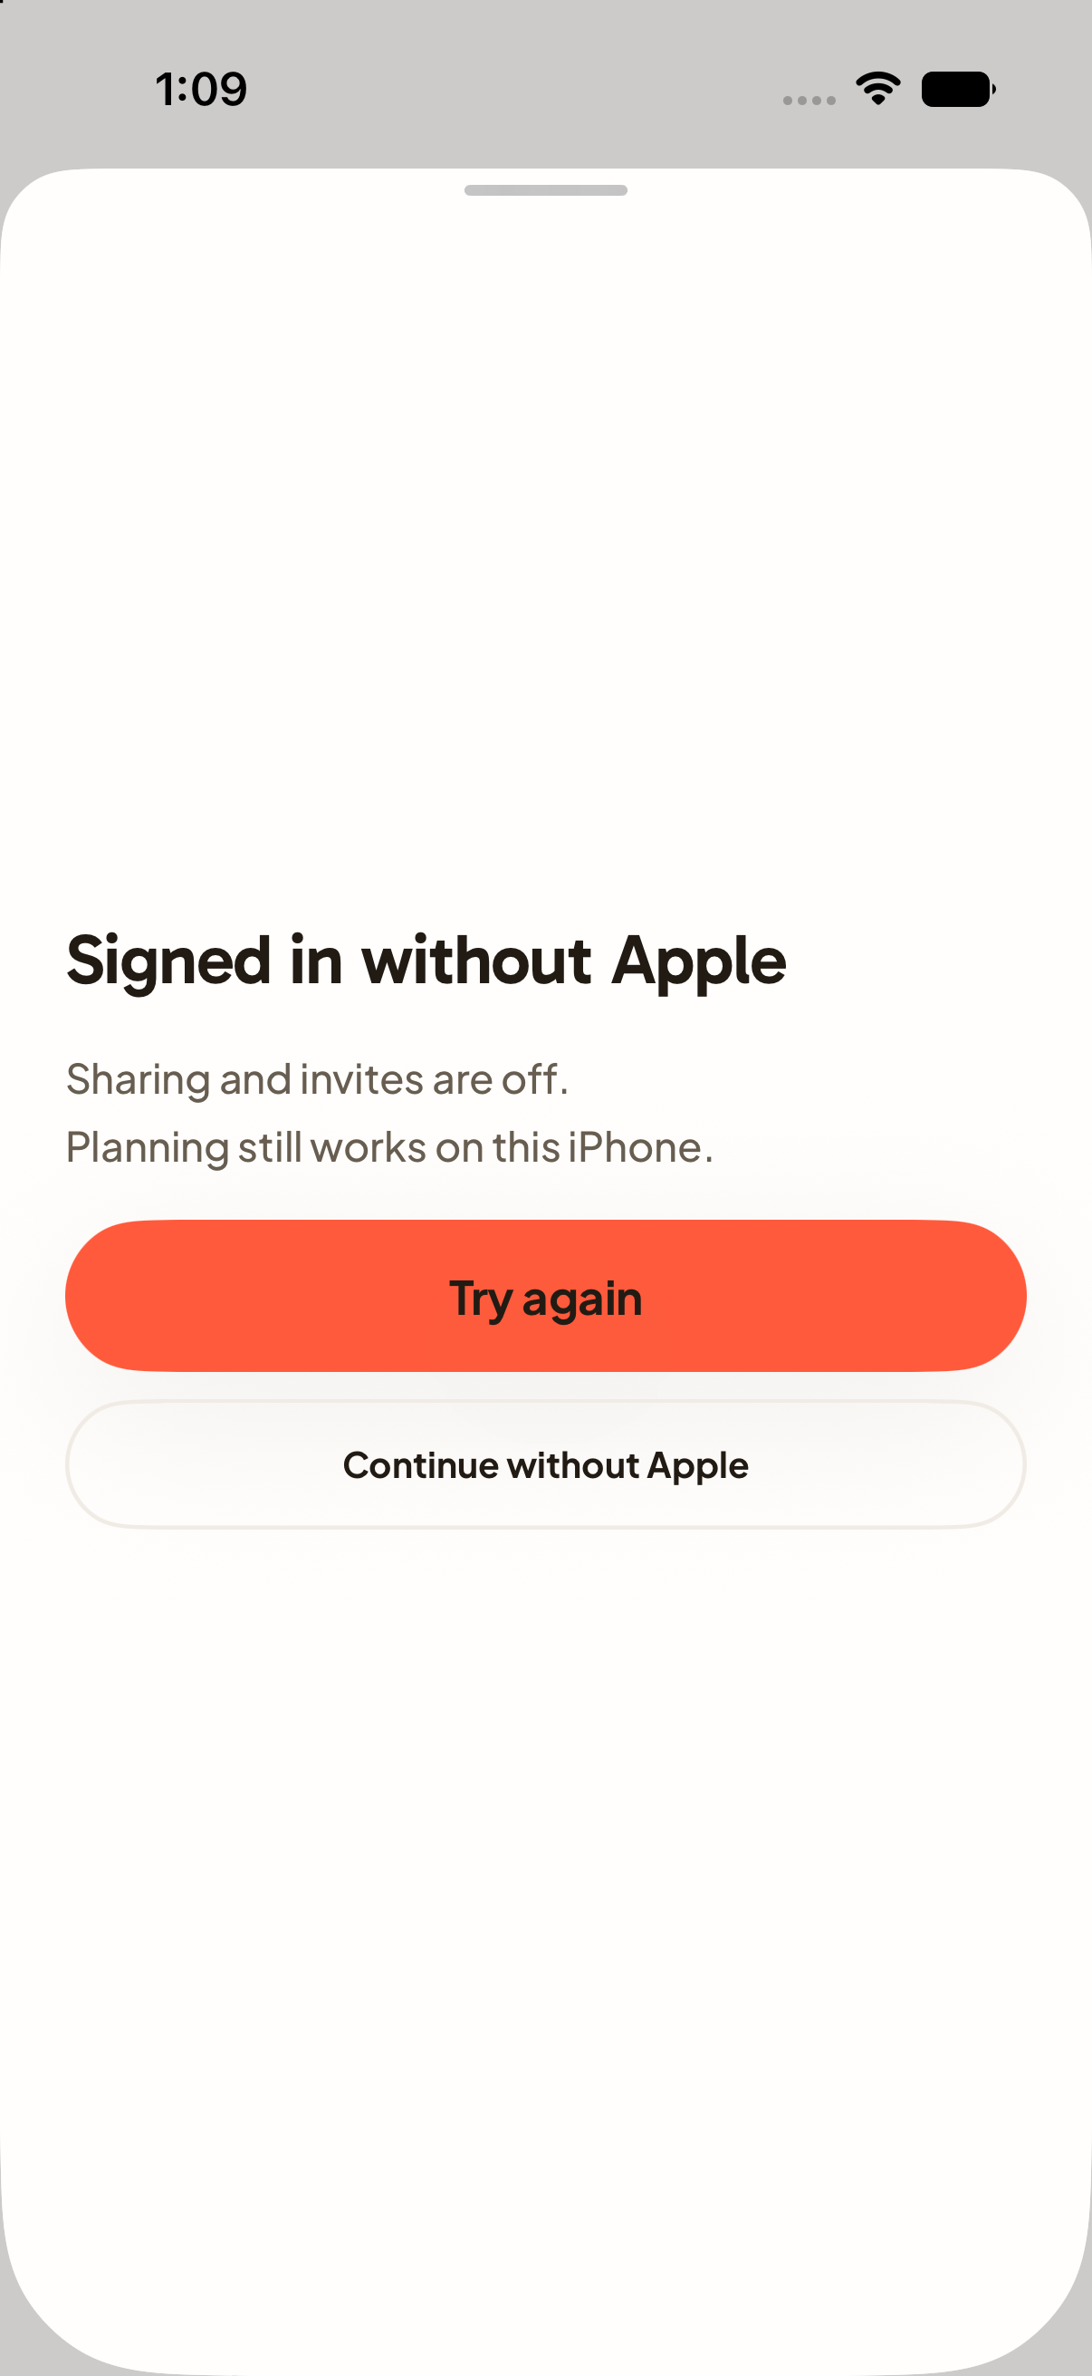  A52 | Decision  Keep / Change / Discuss  Priority  High / Medium / Low  What works  Write feedback here.  What to change  Write feedback here.  Desired result  Write feedback here.

A53 Plated Plus
Feature disabled in the current app navigation
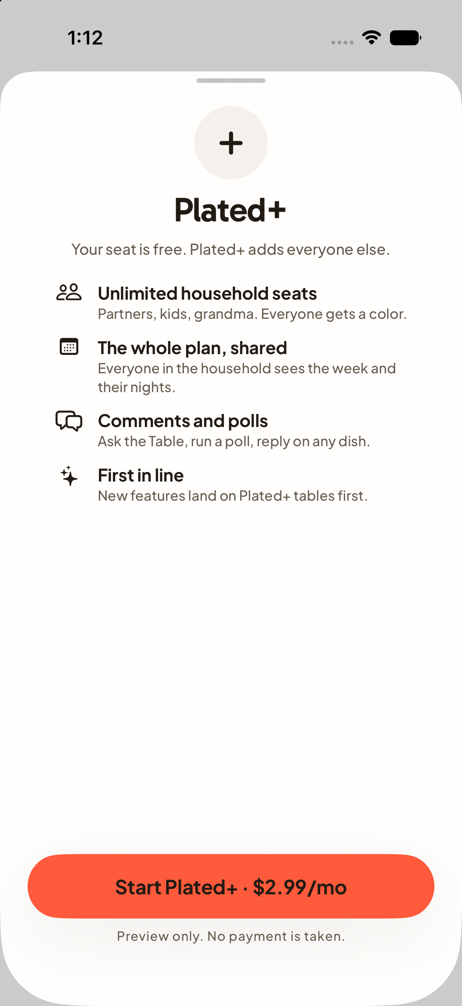  A53 | Decision  Keep / Change / Discuss  Priority  High / Medium / Low  What works  Write feedback here.  What to change  Write feedback here.  Desired result  Write feedback here.

A54 Prongsby
Feature disabled in the current app navigation
A54 | Decision  Keep / Change / Discuss  Priority  High / Medium / Low  What works  Write feedback here.  What to change  Write feedback here.  Desired result  Write feedback here.

A55 Cooking with written steps
Current working tree rendered with sample data
A55 | Decision  Keep / Change / Discuss  Priority  High / Medium / Low  What works  Write feedback here.  What to change  Write feedback here.  Desired result  Write feedback here.

A56 Cooking with active timer
Current working tree rendered with sample data
A56 | Decision  Keep / Change / Discuss  Priority  High / Medium / Low  What works  Write feedback here.  What to change  Write feedback here.  Desired result  Write feedback here.

A57 Household settings
Current working tree rendered with sample data
A57 | Decision  Keep / Change / Discuss  Priority  High / Medium / Low  What works  Write feedback here.  What to change  Write feedback here.  Desired result  Write feedback here.

A58 Plan calendar picker
Current working tree rendered with sample data
A58 | Decision  Keep / Change / Discuss  Priority  High / Medium / Low  What works  Write feedback here.  What to change  Write feedback here.  Desired result  Write feedback here.

A59 Recipe ingredient sheet
Current working tree rendered with sample data
A59 | Decision  Keep / Change / Discuss  Priority  High / Medium / Low  What works  Write feedback here.  What to change  Write feedback here.  Desired result  Write feedback here.

A60 Household badge detail
Current working tree rendered with sample data
A60 | Decision  Keep / Change / Discuss  Priority  High / Medium / Low  What works  Write feedback here.  What to change  Write feedback here.  Desired result  Write feedback here.

A61 Grocery shopping date
Current working tree rendered with sample data
A61 | Decision  Keep / Change / Discuss  Priority  High / Medium / Low  What works  Write feedback here.  What to change  Write feedback here.  Desired result  Write feedback here.

A62 Activity with updates
Current working tree rendered with sample data
A62 | Decision  Keep / Change / Discuss  Priority  High / Medium / Low  What works  Write feedback here.  What to change  Write feedback here.  Desired result  Write feedback here.

W01 Tonight widget small
Widget source layout preview with sample data
W01 | Decision  Keep / Change / Discuss  Priority  High / Medium / Low  What works  Write feedback here.  What to change  Write feedback here.  Desired result  Write feedback here.

W02 Tonight widget medium
Widget source layout preview with sample data
W02 | Decision  Keep / Change / Discuss  Priority  High / Medium / Low  What works  Write feedback here.  What to change  Write feedback here.  Desired result  Write feedback here.

W03 Tonight widget large
Widget source layout preview with sample data
W03 | Decision  Keep / Change / Discuss  Priority  High / Medium / Low  What works  Write feedback here.  What to change  Write feedback here.  Desired result  Write feedback here.

W04 Table widget small
Widget source layout preview with sample data
W04 | Decision  Keep / Change / Discuss  Priority  High / Medium / Low  What works  Write feedback here.  What to change  Write feedback here.  Desired result  Write feedback here.

W05 Table widget medium
Widget source layout preview with sample data
W05 | Decision  Keep / Change / Discuss  Priority  High / Medium / Low  What works  Write feedback here.  What to change  Write feedback here.  Desired result  Write feedback here.

W06 Table widget large
Widget source layout preview with sample data
W06 | Decision  Keep / Change / Discuss  Priority  High / Medium / Low  What works  Write feedback here.  What to change  Write feedback here.  Desired result  Write feedback here.

W07 Cookbook widget small
Widget source layout preview with sample data
W07 | Decision  Keep / Change / Discuss  Priority  High / Medium / Low  What works  Write feedback here.  What to change  Write feedback here.  Desired result  Write feedback here.

W08 Cookbook widget medium
Widget source layout preview with sample data
W08 | Decision  Keep / Change / Discuss  Priority  High / Medium / Low  What works  Write feedback here.  What to change  Write feedback here.  Desired result  Write feedback here.

W09 Grocery widget small
Widget source layout preview with sample data
W09 | Decision  Keep / Change / Discuss  Priority  High / Medium / Low  What works  Write feedback here.  What to change  Write feedback here.  Desired result  Write feedback here.

W10 Grocery widget medium
Widget source layout preview with sample data
W10 | Decision  Keep / Change / Discuss  Priority  High / Medium / Low  What works  Write feedback here.  What to change  Write feedback here.  Desired result  Write feedback here.

W11 Grocery widget large
Widget source layout preview with sample data
W11 | Decision  Keep / Change / Discuss  Priority  High / Medium / Low  What works  Write feedback here.  What to change  Write feedback here.  Desired result  Write feedback here.

W12 Whose turn widget small
Widget source layout preview with sample data
W12 | Decision  Keep / Change / Discuss  Priority  High / Medium / Low  What works  Write feedback here.  What to change  Write feedback here.  Desired result  Write feedback here.

W13 Whose turn widget medium
Widget source layout preview with sample data
W13 | Decision  Keep / Change / Discuss  Priority  High / Medium / Low  What works  Write feedback here.  What to change  Write feedback here.  Desired result  Write feedback here.

W14 Tonight lock screen inline
Widget source layout preview with sample data
  W14 | Decision  Keep / Change / Discuss  Priority  High / Medium / Low  What works  Write feedback here.  What to change  Write feedback here.  Desired result  Write feedback here.

W15 Tonight lock screen circular
Widget source layout preview with sample data
W15 | Decision  Keep / Change / Discuss  Priority  High / Medium / Low  What works  Write feedback here.  What to change  Write feedback here.  Desired result  Write feedback here.

W16 Tonight lock screen rectangular
Widget source layout preview with sample data
W16 | Decision  Keep / Change / Discuss  Priority  High / Medium / Low  What works  Write feedback here.  What to change  Write feedback here.  Desired result  Write feedback here.

W17 Groceries lock screen inline
Widget source layout preview with sample data
W17 | Decision  Keep / Change / Discuss  Priority  High / Medium / Low  What works  Write feedback here.  What to change  Write feedback here.  Desired result  Write feedback here.

W18 Groceries lock screen circular
Widget source layout preview with sample data
W18 | Decision  Keep / Change / Discuss  Priority  High / Medium / Low  What works  Write feedback here.  What to change  Write feedback here.  Desired result  Write feedback here.

W19 Groceries lock screen rectangular
Widget source layout preview with sample data
W19 | Decision  Keep / Change / Discuss  Priority  High / Medium / Low  What works  Write feedback here.  What to change  Write feedback here.  Desired result  Write feedback here.

W20 Whose turn lock screen inline
Widget source layout preview with sample data
W20 | Decision  Keep / Change / Discuss  Priority  High / Medium / Low  What works  Write feedback here.  What to change  Write feedback here.  Desired result  Write feedback here.

W21 Whose turn lock screen circular
Widget source layout preview with sample data
W21 | Decision  Keep / Change / Discuss  Priority  High / Medium / Low  What works  Write feedback here.  What to change  Write feedback here.  Desired result  Write feedback here.

W22 Whose turn lock screen rectangular
Widget source layout preview with sample data
W22 | Decision  Keep / Change / Discuss  Priority  High / Medium / Low  What works  Write feedback here.  What to change  Write feedback here.  Desired result  Write feedback here.

W23 Cook timer live activity
Widget source layout preview with sample data
W23 | Decision  Keep / Change / Discuss  Priority  High / Medium / Low  What works  Write feedback here.  What to change  Write feedback here.  Desired result  Write feedback here.

W24 Cook timer expired
Widget source layout preview with sample data
W24 | Decision  Keep / Change / Discuss  Priority  High / Medium / Low  What works  Write feedback here.  What to change  Write feedback here.  Desired result  Write feedback here.

W25 Dynamic Island expanded layout
Source based layout preview of app content without iOS system chrome
W25 | Decision  Keep / Change / Discuss  Priority  High / Medium / Low  What works  Write feedback here.  What to change  Write feedback here.  Desired result  Write feedback here.

W26 Dynamic Island compact layout
Source based layout preview of app content without iOS system chrome
W26 | Decision  Keep / Change / Discuss  Priority  High / Medium / Low  What works  Write feedback here.  What to change  Write feedback here.  Desired result  Write feedback here.

W27 Dynamic Island minimal layout
Source based layout preview of app content without iOS system chrome
  W27 | Decision  Keep / Change / Discuss  Priority  High / Medium / Low  What works  Write feedback here.  What to change  Write feedback here.  Desired result  Write feedback here.

X01 Share extension sending
Share extension source layout preview
X01 | Decision  Keep / Change / Discuss  Priority  High / Medium / Low  What works  Write feedback here.  What to change  Write feedback here.  Desired result  Write feedback here.

X02 Share extension saved
Share extension source layout preview
X02 | Decision  Keep / Change / Discuss  Priority  High / Medium / Low  What works  Write feedback here.  What to change  Write feedback here.  Desired result  Write feedback here.

